**Electrical System Form FSAE-E 2019**

**Western University**

**Western Formula Racing**

**FSAE North Car Number: 238**

**FSAE Electric Car Number: E229**

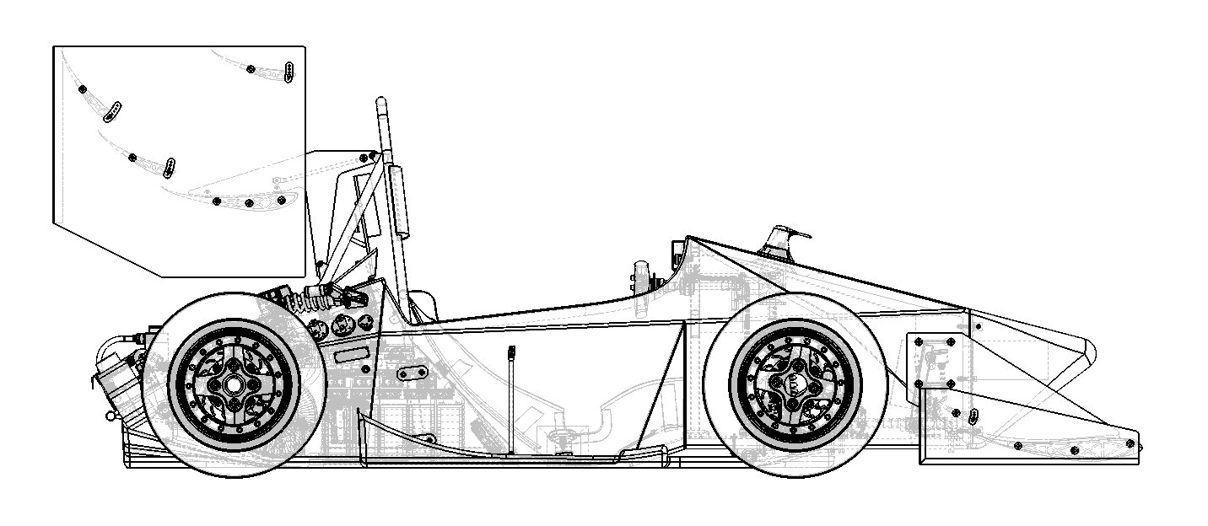



Table of Contents

1 System Overview 7

2 Tractive System Schematics 8

2.1 Tractive System Schematic (Power Electronics ONLY) 8

3 Shutdown Circuit 10

3.1 Shutdown Circuit Schematic 10

3.2 Wiring 11

3.3 IMD 11

3.4 Brake System Plausibility Device 15

3.5 Battery Management System 20

4 Safety Systems 21

4.1 TSAL 21

4.2 Measurement Points 25

4.3 HVD 28

4.4 Ready to Drive Sound 29

5 Accumulator 32

5.1 Accumulator Schematic 32

5.2 Cells 33

5.3 Segments 37

5.4 Precharge Circuit 43

5.5 BMS 46

5.6 AIR 50

5.7 Accumulator Indicator 50

5.8 Mechanical 52

5.9 Charging 53

6 Motor Controller 55

6.1 Controls Architecture/Torque Security 55

6.2 Galvanic Isolation 57

7 Other Items 58

7.1 Energy Meter 58

7.2 Firewall 59

7.3 Grounding 60

7.4 Other Components 61

8 Appendix 65

8.1 SDS (MSDS) of accumulator cell 65

Table of Figures

Figure 1‑1 - System Block Diagram 7

Figure 2‑1 - HV System Schematic 8

Figure 3‑1 - Shutdown Circuit Schematic 10

Figure 3‑2 - Shutdown Circuit Switch Locations 11

Figure 3‑3 - IMD Latch Circuit Schematic 12

Figure 3‑4 - IMD Reset Location 13

Figure 3‑5 - IMD Indicator Light Position 13

Figure 3‑6 - IMD Location in Accumulator 14

Figure 3‑7 - BSPD Schematic 17

Figure 3‑8 - BSPD Component Location 19

Figure 4‑1 - HV Sensing Circuit 22

Figure 4‑2 - TSAL Circuit Schematic 23

Figure 4‑3 - TSAL Location on Rollhoop 24

Figure 4‑4 - TSAL Component Locations 24

Figure 4‑5 - Measurement Point Location 25

Figure 4‑6 - TSMP Protection Cover 26

Figure 4‑7 - TSMP Protection Resistor Location 27

Figure 4‑8 - HVD Location 28

Figure 4‑9 - Discharge Circuit Component Locations 31

Figure 5‑1 - Accumulator Schematics 32

Figure 5‑2 - Cell Connection Detail 34

Figure 5‑3 – Fuse blow time vs. current 35

Figure 5‑4 – Energus cell fuse 35

Figure 5‑5 – Blow Time vs Accumulator Current 36

Figure 5‑6 - Cell Mounting in Accumulator 37

Figure 5‑7 – Accumulator CAD of segments 39

Figure 5‑8 – Intake/Gore-tex barrier to accumulator 40

Figure 5‑9 – CAD of maintenance plugs 41

Figure 5‑10 - Maintenance Plug Locations 41

Figure 5‑11 – Maintenance plug latches 42

Figure 5‑12 – Precharge circuit schematic 43

Figure 5‑13 – Precharge circuit PCB layout 44

Figure 5‑14 - Precharge Circuit Location 44

Figure 5‑15 – Precharge voltage vs. time 45

Figure 5‑16 – Precharge circuit specifications 45

Figure 5‑17 – Temperature Sensor Output 47

Figure 5‑18 – Temperature Sensor Configuration 48

Figure 5‑19 - Location of Temperature Sensors 48

Figure 5‑20 – Voltage Sense Leads 49

Figure 5‑21 - BMS Location 50

Figure 5‑22 - Accumulator Indicator Light Mosfet Output 51

Figure 5‑23 - Schematic of Accumulator Indication 52

Figure 5‑24 - AIR and Fuse Separation 53

Figure 5‑25 - Charging Shutdown Circuit Schematic 54

Figure 5‑26 - Charging TS Schematic 54

Figure 6‑1 - APPS voltage vs. position 56

Figure 6‑2 - Toque Control Signal Path 57

Figure 7‑1 - Energy Meter Location 58

Figure 7‑2 - Energy Meter Internal Layout 58

Figure 7‑3 - Firewall Location 59

Figure 7‑4 - DC/DC Converter Board Layout 61

Figure 7‑5 – DC/DC Converter Schematic 61

Figure 7‑6 - HVIB Circuit Schematic 63

Figure 7‑7 - HVIB PCB Layout 64

Table of Tables

Table 1‑1 - High Level Specifications 7

Table 2‑1- Fuse Tree Diagram 8

Table 2‑2 - Fuse Specifications 8

Table 2‑3 - Conductor Specifications 9

Table 2‑4- Connector Specifications 9

Table 3‑1 - Shutdown Circuit Loads 11

Table 3‑2 - IMD Specifications 11

Table 3‑3 - BSPD Current Sensor Specifications 15

Table 3‑4 - BSPD Operation Details 15

Table 4‑1 - TSAL Specifications 21

Table 4‑2 - Measurement Point Specifications 25

Table 4‑3 - TSMP Protection Resistor Specifications 26

Table 4‑4 - HVD Specifications 28

Table 4‑5 - RTDS Specifications 29

Table 4‑6 - Discharge Resistor Specifications 30

Table 4‑7 - Discharge Relay Specifications 30

Table 5‑1 - Cell Specifications 33

Table 5‑2 - Segment Specifications 37

Table 5‑3 - Maintenance Plug Connector Specification 40

Table 5‑4 - Precharge Resistor Specifications 43

Table 5‑5 - Precharge Relay Specifications 43

Table 5‑6 - Temperature Sensor Specifications 47

Table 5‑7 - BMS Setpoints 49

Table 5‑8- AIR Specifications 50

Table 5‑9 - Charger Specifications 53

Table 7‑1 - Firewall Specifications 59

Table 7‑2 – DC/DC Converter Bill of Materials 62

Abbreviations

AIR – Accumulator Insulation Relay

AMS- Accumulator Monitoring System

BMS- Battery Monitoring System

BOTS – Brake-Over-Travel-Switch

BSPD – Brake System Plausibility Device

GLV – Grounded Low Voltage

GLVMP – Ground Low Voltage Measurement Point

HV – High Voltage

IMD – Insulation Monitoring Device

TS – Tractive System

TSAL – Tractive System Active Light

TSMP – Tractive System Measurement Point

HVIB – High Voltage Interlock Board

# System Overview

The vehicle has a single EMRAX 228 MV LC motor driving the rear axle via a differential and a step-down gearbox. The motor is powered by a Rinehart PM100DXR inverter running on a 400VDC bus. The inverter is acting as a CAN-bus slave to a Motec M150 ECU. The M150 is running on custom firmware developed by the team and handles all non-hardware safety functions as well as torque commands and data logging. All low voltage components on the vehicle run on either 12VDC or 5VDC.

|  |  |
| --- | --- |
| Maximum Tractive System Voltage: | 399VDC |
| Nominal Tractive System Voltage: | 342VDC |
| Grounded Low Voltage System Voltage: | 5VDC, 12VDC |
| Number of Accumulator Containers: | 1 |
| Total Accumulator Capacity: | 7.182kWhr |
| Motor Type: | Synchronous Permanent Magnet, Axial Flux |
| Number of Motors: | 1 |
| Maximum Combined Motor Power: | 100kW |

Table 1‑1 - High Level Specifications

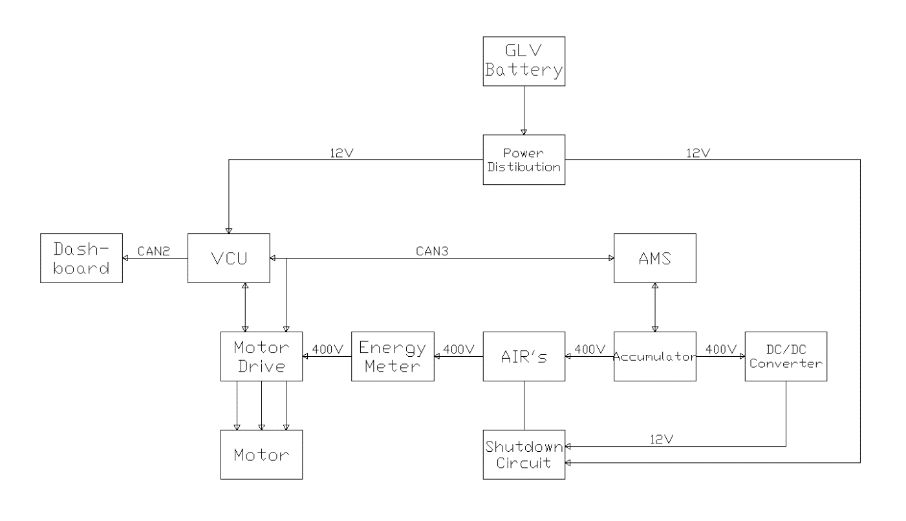

Figure 1‑1 - System Block Diagram

# Tractive System Schematics

## Tractive System Schematic (Power Electronics ONLY)

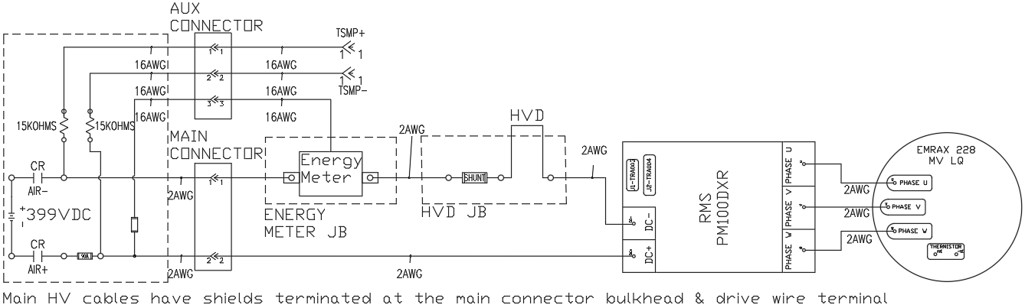

Figure 2‑1 - HV System Schematic

Fusing Diagram

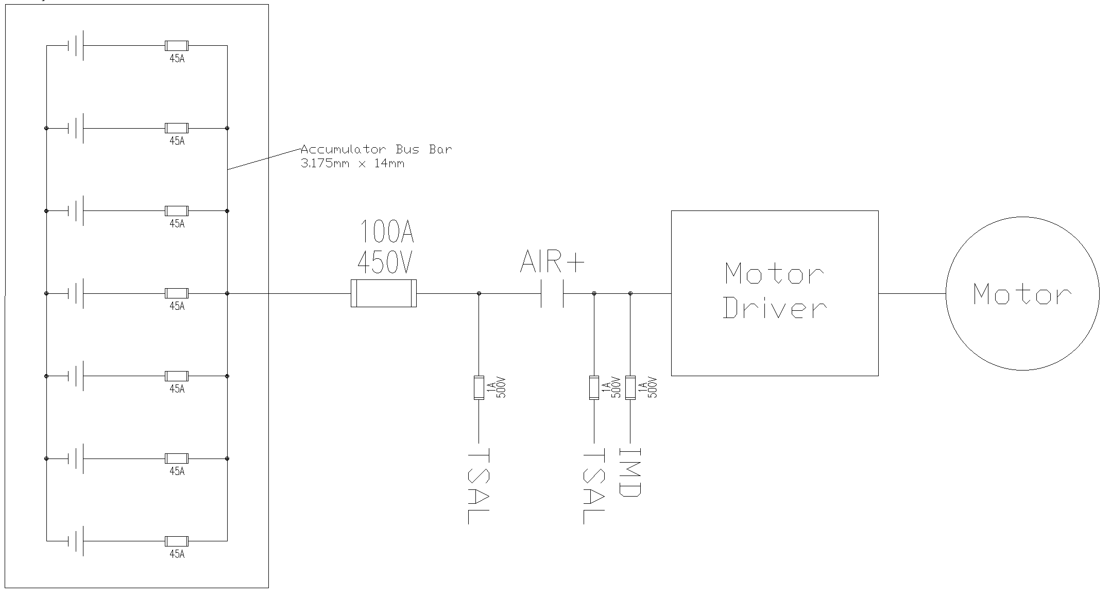

Table 2‑1- Fuse Tree Diagram

### Fuse Specifications

|  |  |  |  |  |  |  |  |  |
| --- | --- | --- | --- | --- | --- | --- | --- | --- |
| **Fuse Location** | | **Current Rating** | **Voltage Rating** | | **Interrupt Rating** | | **Datasheet** | |
| Main Path Fuse inside AIR + Container L50S100 | | 100A | 450 V | | 20KA | | [Link](https://www.littelfuse.com/~/media/electrical/datasheets/fuses/semiconductor-fuses/littelfuse-fuse-l50s-datasheet.pdf) | |
| Charger output | 30A | 500V | | 30kA@500VAC 20kA@500VDC | | [Link](https://www.littelfuse.com/~/media/electronics/datasheets/fuses/littelfuse_fuse_505_datasheet.pdf.pdf) | |
| Cell Fuses – Within Energus Modules | | 45A | N/A | | N/A | | See Figure 6-3 | |
| TSAL Sense Line HVIB | | 1A | 500 V | | 100A | | [Link](https://media.digikey.com/pdf/Data%20Sheets/Littelfuse%20PDFs/885_Series_Fuse.pdf) | |
| TSAL Sense Line HVIB | | 1A | 500 V | | 100A | | [Link](https://media.digikey.com/pdf/Data%20Sheets/Littelfuse%20PDFs/885_Series_Fuse.pdf) | |
| IMD Sense Line HVIB | | 1A | 500 V | | 100A | | [Link](https://media.digikey.com/pdf/Data%20Sheets/Littelfuse%20PDFs/885_Series_Fuse.pdf) | |

Table 2‑2 - Fuse Specifications

### Conductor Specifications

|  |  |  |  |  |  |  |
| --- | --- | --- | --- | --- | --- | --- |
| **Conductor Location** | **Size** | **Voltage Rating** | **Ampacity** | **Rating of fuse providing protection** | **Temperature Rating** | **Datasheet** |
| Cell Busbars | 44.45mm2 | NA | 205A | 20A | NA | Team Manufactured |
| Tractive System DC/Phase Wire | 35mm2 | 1000V | 158A | 100A | -45°C to 150°C | [Datasheet](https://www.iewcsolutions.co.uk/assets/specsheets/Champlain%20EXRAD%20HVFX%2035MM%20XLE%20SHLD%20Spec.pdf) |
| Accumulator Wire | 35mm2 | 600V | 158A | 100A | -70C to 150C | [Datasheet](https://www.champcable.com/wp-content/uploads/2019/01/29.-EXAR-150-SFX-Oil-Res-UL3271-UL3289R3.pdf) |
| TSMP / HV Sense Wire | 16AWG | 600V | 13A | No fuse on TSMP | -68C to 150C | [Datasheet](https://www.te.com/commerce/DocumentDelivery/DDEController?Action=srchrtrv&DocNm=55A0811&DocType=Customer+Drawing&DocLang=English) |

Table 2‑3 - Conductor Specifications

### Connector Specifications

|  |  |  |  |  |  |  |
| --- | --- | --- | --- | --- | --- | --- |
| **Connector Location** | **Ampacity** | **Voltage Rating** | **Includes Interlock** | **Accepted wire gauge** | **Wire gauge connected** | **Datasheet** |
| Accumulator Main Receptacle | 200A | 850V | Yes | All | 2 AWG | [Link](https://www.te.com/commerce/DocumentDelivery/DDEController?Action=showdoc&DocId=Specification+Or+Standard%7F114-94153%7FB%7Fpdf%7FEnglish%7FENG_SS_114-94153_B.pdf%7FN-A) |
| Accumulator Main Plug | 200A | 850V | Yes | 25-50 mm^2 | 35mm^2 | [Link](https://www.te.com/commerce/DocumentDelivery/DDEController?Action=showdoc&DocId=Specification+Or+Standard%7F114-94052%7FG%7Fpdf%7FEnglish%7FENG_SS_114-94052_G.pdf%7FN-A) |
| High Voltage Disconnect | 630A | 1KV | Yes | All | 35mm^2 | [Link](https://www.te.com/commerce/DocumentDelivery/DDEController?Action=showdoc&DocId=Specification+Or+Standard%7F408-10377%7FB%7Fpdf%7FEnglish%7FENG_SS_408-10377_B.pdf%7FN-A) |
| Accumulator Aux Receptacle (TSMP & Energy Meter lines) | 13A | 600V | Yes | 30-14 AWG | 18 AWG | [Link](https://www.te.com/commerce/DocumentDelivery/DDEController?Action=showdoc&DocId=Catalog+Section%7F82021_CPC_sections1-5%7F0807%7Fpdf%7FEnglish%7FENG_CS_82021_CPC_sections1-5_0807.pdf%7F796272-1)  (PN 796272-1) |
| Accumulator Aux Plug (TSMP & Energy Meter lines) | 13A | 600V | Yes | 30-14 AWG | 18 AWG | [Link](https://www.te.com/commerce/DocumentDelivery/DDEController?Action=showdoc&DocId=Catalog+Section%7F82021_CPC_sections1-5%7F0807%7Fpdf%7FEnglish%7FENG_CS_82021_CPC_sections1-5_0807.pdf%7F796272-1)  (PN  796271-1) |

Table 2‑4- Connector Specifications

# 

# Shutdown Circuit

## Shutdown Circuit Schematic

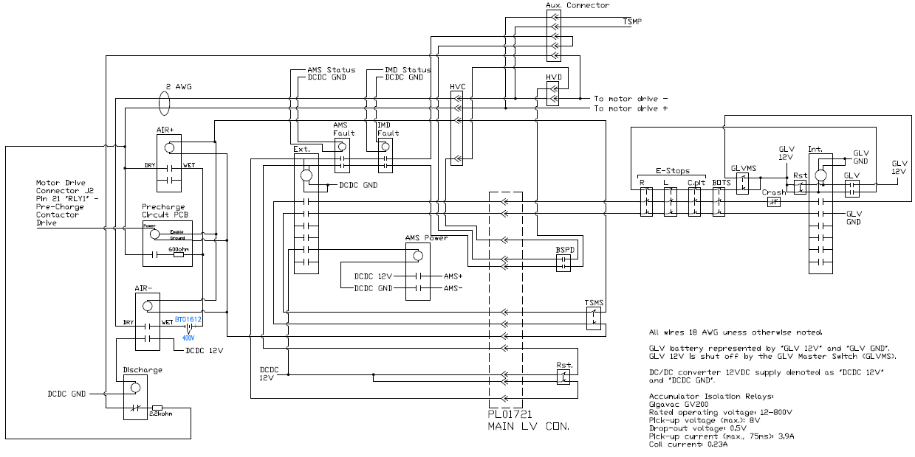

The “aux” connector is used to ensure that the capacitance of the motor drive can discharge even when the HVD is removed from the vehicle.

Figure 3‑1 - Shutdown Circuit Schematic

### Switch Locations

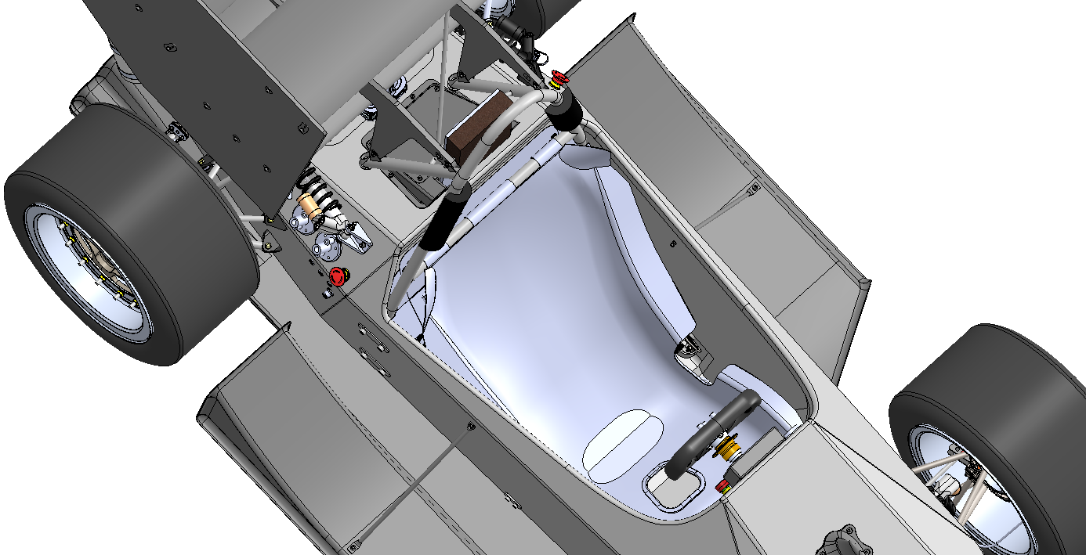

**Emergency Stops**

**Traction Master Switch**

**GLV Master Switch**

Figure 3‑2 - Shutdown Circuit Switch Locations

## Wiring

### Shutdown Circuit Current

|  |  |
| --- | --- |
| Total Number of AIR’s: | 2 |
| Current per AIR: | 0.23A (holding), 3.9A (inrush) |
| Additional parts consumption within the shutdown circuit: | 0.17A (Discharge relay holding current) |
| Total current: | 0.63A |

Table 3‑1 - Shutdown Circuit Loads

## IMD

### IMD Specifications

|  |  |
| --- | --- |
| Make / Model | Bender IR155-3203 |
| Supply voltage | 12VDC |
| Environmental temperature range: | -40..+105°C |
| Self-test interval: | Every 5 minutes |
| High voltage range: | DC 0..1000V |
| Set response value: | 200kΩ (500Ω/Volt) |
| Max. operation current: | 150mA |
| Approximate time to shut down at 50% of the response value: | 40s |
| Datasheet | [Datasheet](http://www.bender-emobility.com/fileadmin/products/doc/IR155-32xx-V004_D00115_D_XXEN.pdf) |

Table 3‑2 - IMD Specifications

### IMD Fault Latching

Latching for all devices in the safety circuit is accomplished using a relay configuration with two channels. The relays used for each channel are interlocked with each other so that each will not turn on without the other being on as well. Once there is a fault (i.e. one or both channels goes low), neither relay will be able to turn on unless the reset button is pushed. The third relay that operates the six normally-open output contacts is powered through a contact on each of the channel relays. Thus, it will only close the contacts when there is power to both channel relays.

There are three such dual-channel relay configurations in the vehicle. These are shown in a simplified manner in the Shutdown System Schematic as “Ext.” (External) and “Int.” (Internal), ~~and “Mon.” (Monitor)~~. The IMD is part of the circuit controlling the “Ext.” relay module.

The IMD has a high-side output to control its associated NO relay. If the output is floating, it will not be able to close the relay. See Figure 4-1 for how the IMD’s relay connects to the safety circuit.

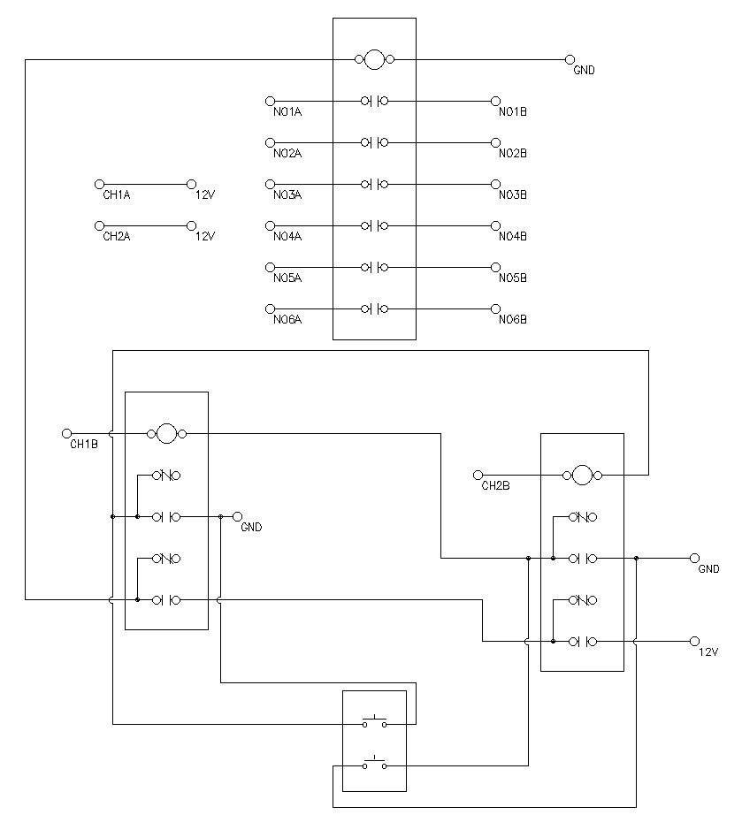

Figure 3‑3 - IMD Latch Circuit Schematic

### IMD Location

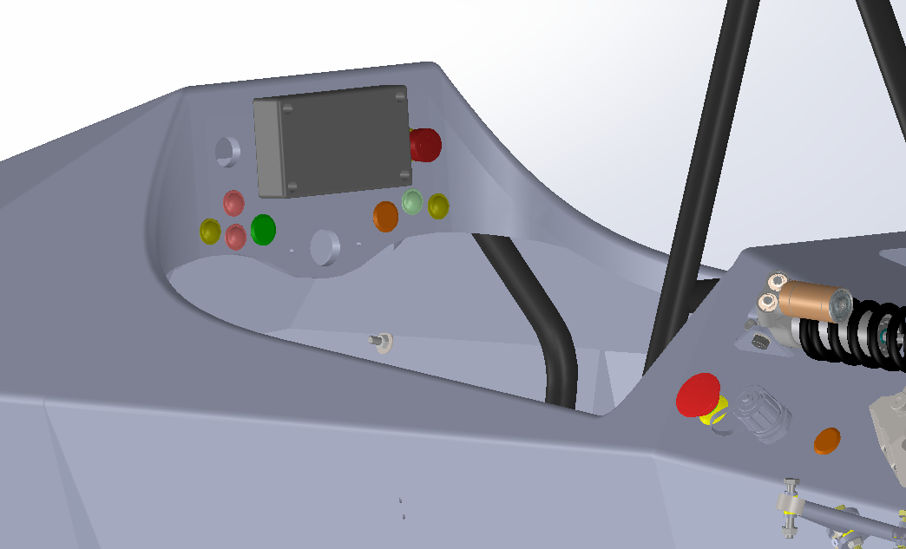

**Reset Button**

Figure 3‑4 - IMD Reset Location

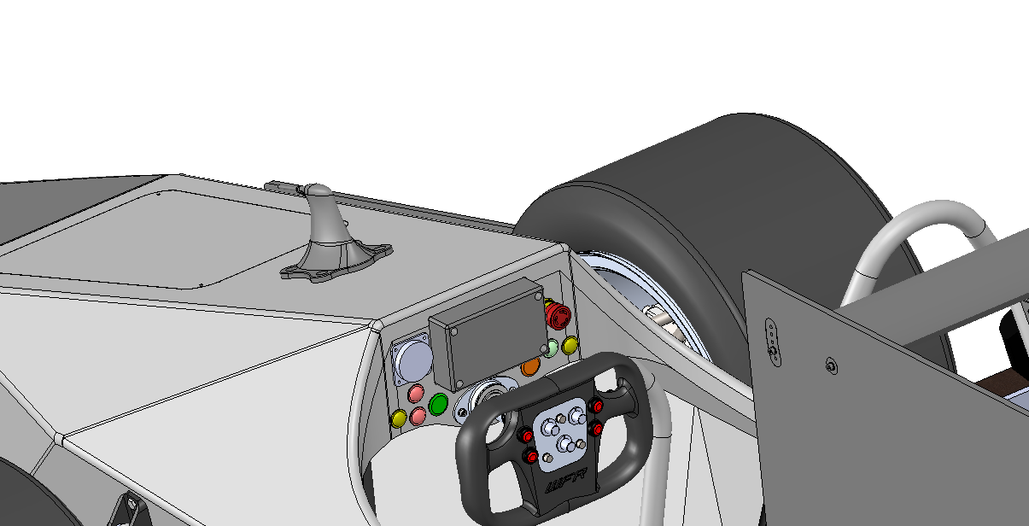

**IMD Indicator Light**

Figure 3‑5 - IMD Indicator Light Position

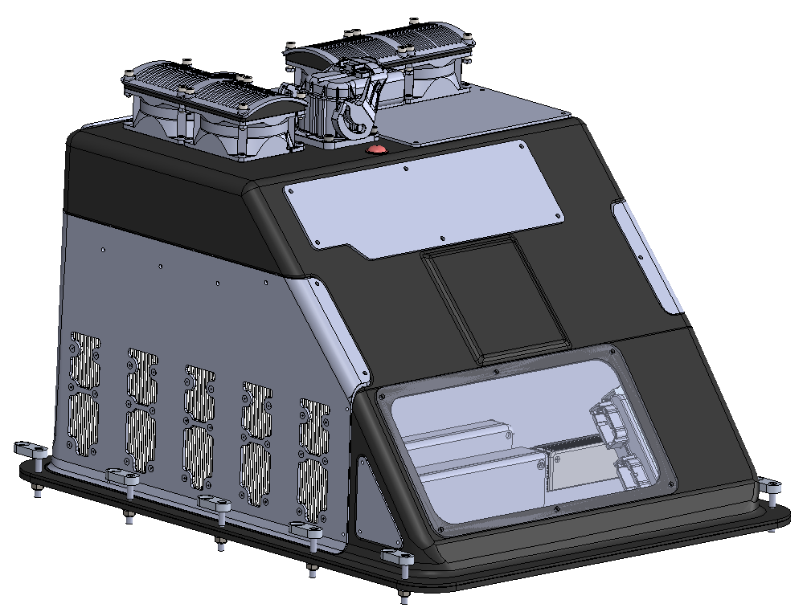

**IMD**

Figure 3‑6 - IMD Location in Accumulator

### IMD Demonstration

1. Power on tractive system using the Tractive System Master Switch
2. Connect one end of a 50kΩ resistor (50% of 250V/Ω as per rule IN.4.4.2) to the negative TSMP measuring point. The resistor is a through hole resistor soldered to a lead.
3. Choose a grounded location on the vehicle and connect the other side of the resistor to that location using an alligator clip.
4. Wait up to 30 seconds to observe the IMD shut down the tractive system
5. Turn the TSMS to the off position
6. Remove the resistor from the negative TSMP and disconnect the grounded location.
7. Turn the TSMS to the on position.
8. Reset the safety system using the external reset button located on the side of the vehicle behind the driver.
9. Repeat steps 2 through 8 to test other vehicle locations

## Brake System Plausibility Device

### BSPD Current Sensor

|  |  |
| --- | --- |
| Make / Model: | LEM / DHAB S/124 |
| Current input range: | +/- 75A Ch1, +/- 500A Ch2 |
| Output range: | 0.25-4.75V |
| Datasheet: | [Datasheet](https://www.lem.com/sites/default/files/products_datasheets/dhab_s_124.pdf) |

Table 3‑3 - BSPD Current Sensor Specifications

### BSPD Setpoint

|  |  |
| --- | --- |
| Trip Current | 12.5A |
| Current sensor output @Trip Current | 2.83V |
| Delay time | 4.05ms |

Table 3‑4 - BSPD Operation Details

### BSPD Schematic

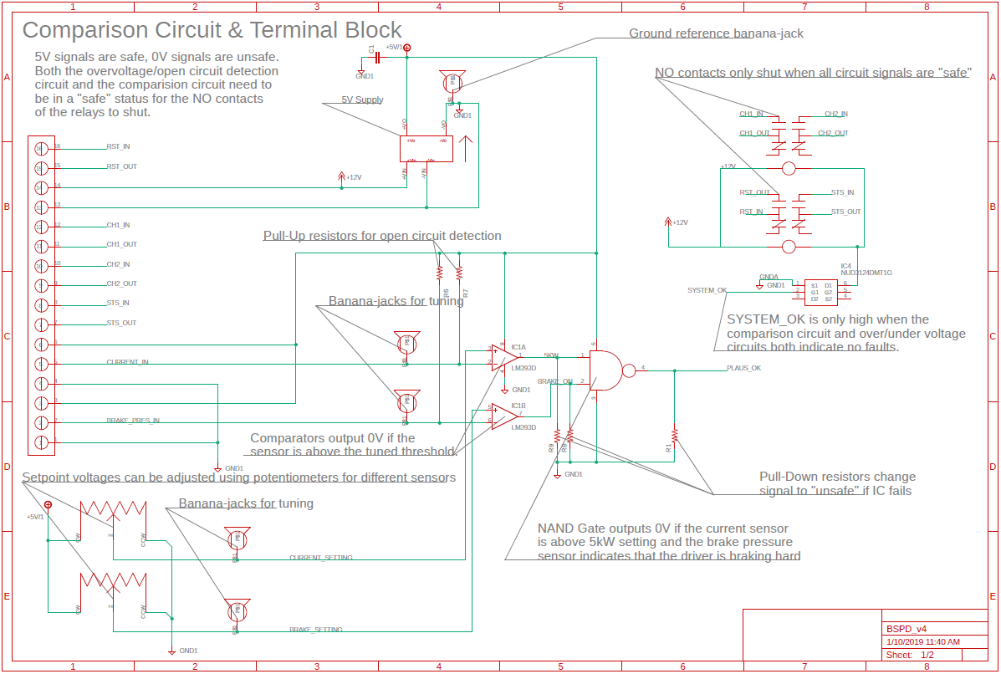

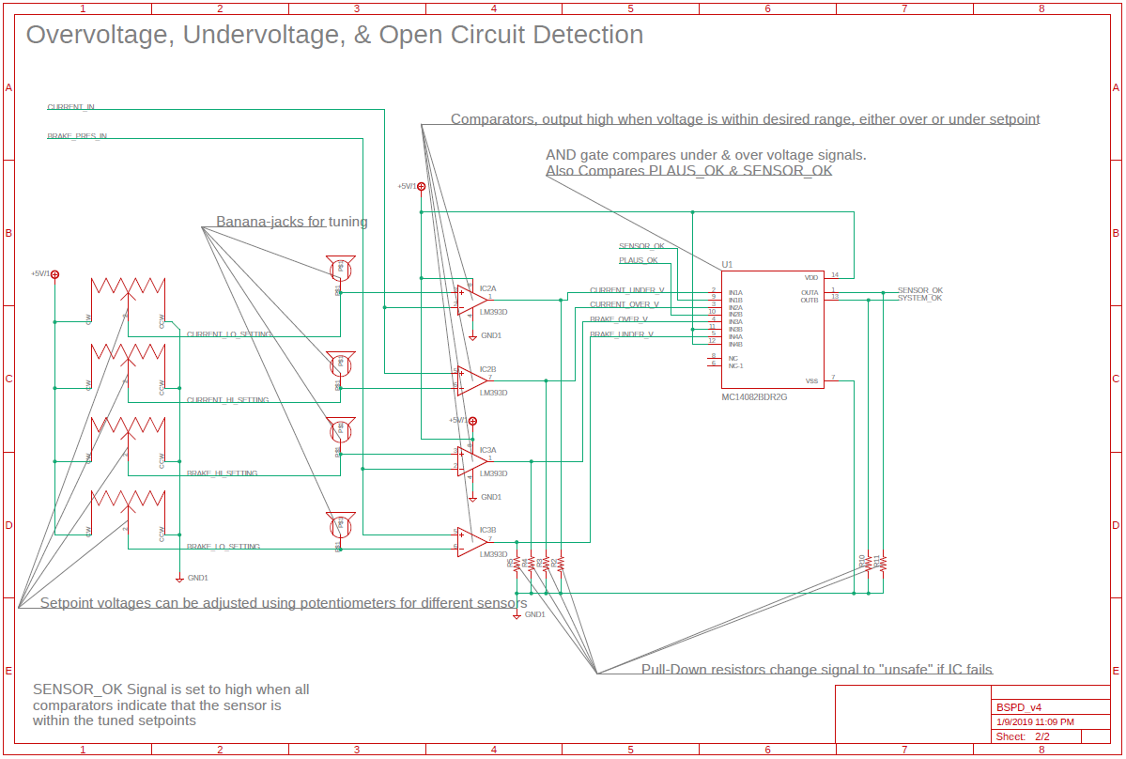

Figure 3‑7 - BSPD Schematic

The tuning potentiometers in the schematic are used during testing to verify that the calculated setpoints are correct. If there are any issues with the setpoints, they are adjusted using the potentiometers. Once testing is finished, the potentiometers will be replaced with through hole resistors.

|  |  |  |
| --- | --- | --- |
| BSPD Terminal | Name | Description |
| 1 | GND | Connected to GLV ground |
| 2 | BRAKE PRESSURE IN | Connected to brake pressure sensor feedback. |
| 3 | SENSOR +5V | 5V supply for brake pressure sensor. |
| 4 | GND | Connected to GLV ground |
| 5 | CURRENT IN | Connected to current sensor feedback. |
| 6 | SENSOR +5V | 5V supply for current sensor. |
| 7 | STS_OUT | NO contact, continuous to terminal 8 when BSPD is “safe”. |
| 8 | STS_IN | NO contact, continuous to terminal 7 when BSPD is “safe”. |
| 9 | CH2_OUT | NO contact, continuous to terminal 10 when BSPD is “safe”. |
| 10 | CH2_IN | NO contact, continuous to terminal 9 when BSPD is “safe”. |
| 11 | CH1_OUT | NO contact, continuous to terminal 12 when BSPD is “safe”. |
| 12 | CH1_IN | NO contact, continuous to terminal 11 when BSPD is “safe”. |
| 13 | GND | Connected to GLV ground |
| 14 | +12V | +12V Fused input supplied from the power distribution module. |
| 15 | RST_OUT | NO contact, continuous to terminal 16 when BSPD is “safe”. |
| 16 | RST_IN | NO contact, continuous to terminal 15 when BSPD is “safe”. |

### BSPD Location

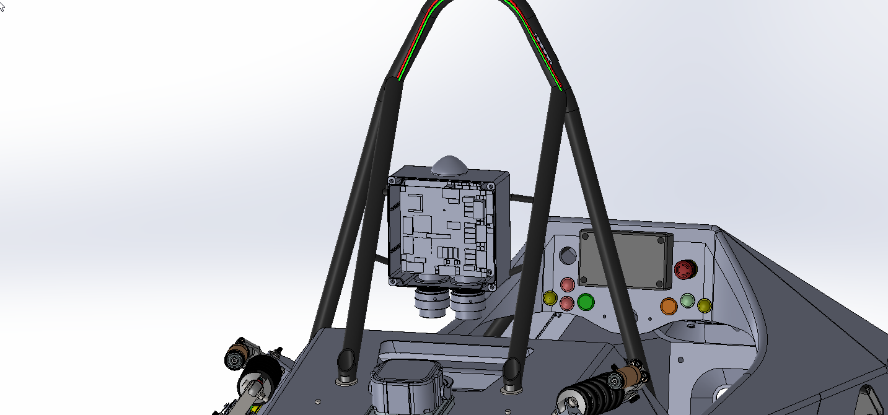

**Power Distribution Module**

**BSPD**

Figure 3‑8 - BSPD Component Location

### BSPD Demonstration

The BSPD demonstration is performed as follows:

* Connect power supply to the test resistor, and the testing points located in the rear of the car
* Go through the car start up procedures to place it in ready to drive mode
* Ensure that TSAL indicates HV is present and that the accumulator indicator light is on.
* Adjust current output from the power supply until it reads 12.5A. The brake pedal should also be depressed.
* Observe TSAL or Accumulator Light to determine if the BSPD de-activated the tractive system.
* Turn off test current.
* Reset both safety circuits. The internal reset should not Enable HV. Confirm this by making sure the TSAL is GREEN
* Power down the vehicle by moving the TSMS and GLVMS to the off position.
* Unscrew the +12V lead of the BSPD
* Turn on GLVMS and TSMS.
* Reset both safety circuits. The internal reset should not Enable HV. Confirm this by making sure the TSAL is GREEN
* Power down the vehicle by moving the TSMS and GLVMS to the off position.
* Reconnect the +12V lead
* Unplug the brake pressure sensor
* Turn on GLVMS and TSMS.
* Reset both safety circuits. The internal reset should not Enable HV. Confirm this by making sure the TSAL is GREEN
* Power down the vehicle by moving the TSMS and GLVMS to the off position.
* Reconnect the brake pressure sensor.
* Unplug the current sensor.
* Turn on GLVMS and TSMS.
* Reset both safety circuits. The internal reset should not Enable HV. Confirm this by making sure the TSAL is GREEN
* Power down the vehicle by moving the TSMS and GLVMS to the off position.
* Reconnect the brake pressure sensor
* Reset both safety circuits. The internal reset should Enable HV. Confirm this by making sure the TSAL is RED.

Note that only the internal safety circuit can be reset from within the vehicle (faults that do not include the AMS, BSPD, or IMD). The external safety circuit has a reset button located on the side of the car which can be used to reset the AMS, BSPD, or IMD in order to comply with EV 7.2.6.

## Battery Management System

### BMS Faults

The following faults will cause the Orion BMS 2 to open the shutdown circuit:

* Over-voltage or cells above 4.2V
* Under-voltage of cells below 2.5V
* If the BMS is reading less than 20% of cell temperatures
* Cells are over 60C or under –20C
* If the Current draw from the cells is above the limit conditions determined by voltage, temperature, and state of charge.
* If the BMS determines there is a fault in any of its voltage tap connections
* If there is a fault in the current sensor

### BMS Fault Latching

The BMS fault latching functionality is achieved through use of a dual-channel relay module as described in further detail in section 3.3.2. The BMS fault relay is part of the “Ext.” relay circuit and, as such, requires the reset on the exterior of the vehicle to be depressed before the AIR’s will close again.

### BMS Demonstration

Perform the following:

1. Turn on the GLV system.
2. Connect to the Ewert CANdapter to the CAN network on the car (via connector outside the accumulator).
3. Open Orion BMS 2 Software Utility on a Windows PC and connect to the CANdapter.
4. View live parameters in the software.
   1. View cell temperatures
   2. View cell voltages
5. Within software utility show all conditions that will trigger opening of AIR
   1. Manipulate fault conditions to trigger fault to occur.
   2. Example: lower max temp to ambient and watch fault open AIR’s
6. Hit safety reset onside accumulator while fault is occurring to show fault latching
7. Remove fault condition and hit safety reset to show reset works.

1. Turn the GLV System ON 2. Connect to the Sensor CAN Bus (BMS is on this bus) at 1000 kbit/s 3. Send CAN request to broadcast all cell voltages and temperatures 4. Display CAN Bus traffic with symbols database to show the voltages and temperatures of all the cells 5. Display code snippets for conditions to open the AIR’S

# Safety Systems

## TSAL

### TSAL Specifications

|  |  |
| --- | --- |
| Make/Model: | Adafruit / 3860 |
| Color: | Red |
| Flash Rate: | 4Hz |
| Powered By: | GLV |
| Controlled By: | TS |
| TS Turn On Voltage: | 10V |
| TS Turn Off Voltage: | 10V |

Table 4‑1 - TSAL Specifications

### TSAL Schematic

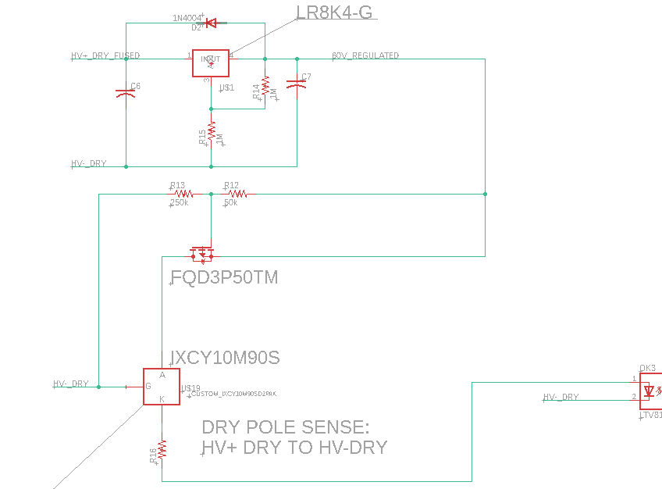

Figure 4‑1 - HV Sensing Circuit

U$19 Part number is IXCY10M90S [datasheet](https://ixapps.ixys.com/DataSheet/DS98729A(IXCP-CY10M90S).pdf). HV+ Dry and HV- Dry are the motor controller side of the AIR’s.

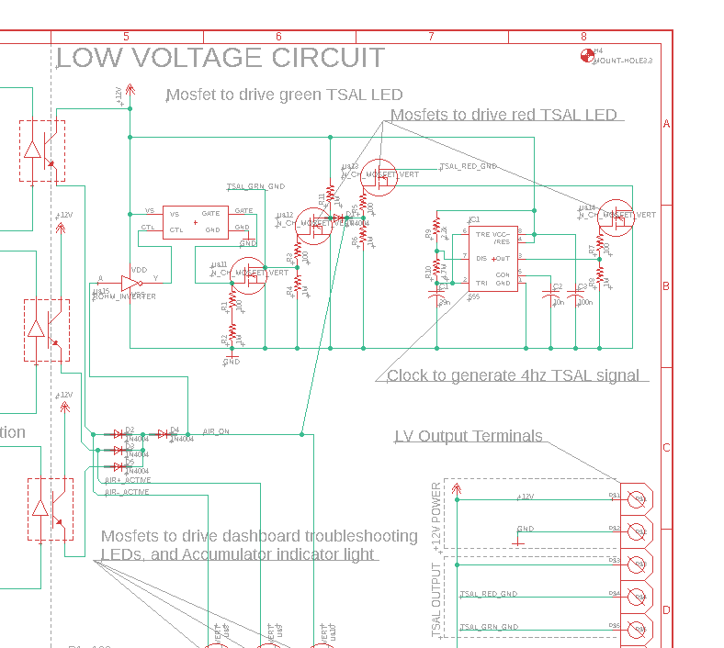

Figure 4‑2 - TSAL Circuit Schematic

The HV detection circuit works by means of the current regulators on the high voltage side of the HVIB. The current regulators are coupled with an opto isolators to transmit the signals to the LV side of the board. These sensing circuits have their sense leads attached on both poles of the AIR’s and measure between HV+ Dry and HV- Dry (dry pole sense),

### TSAL Location

The TSAL circuit is located on the roll hoop and is mounted as shown below:

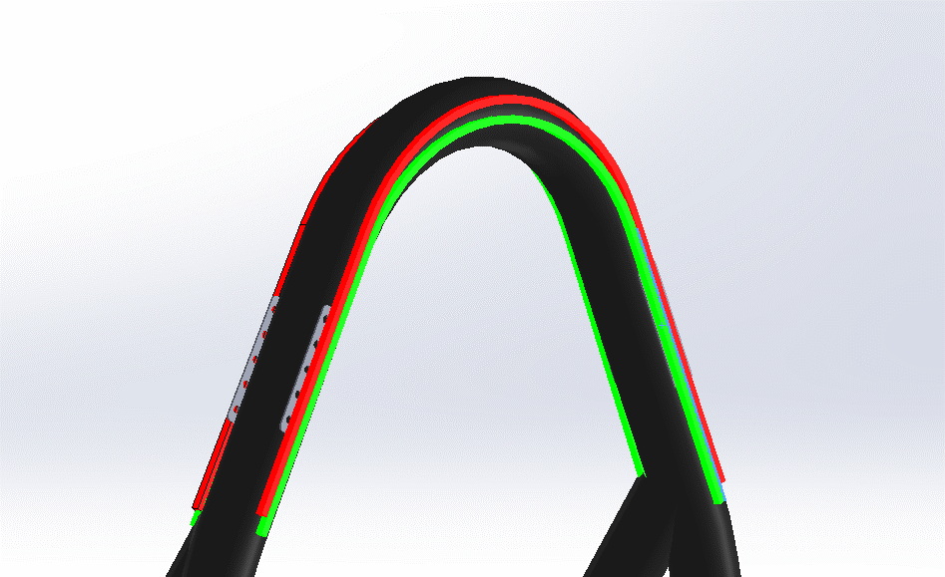

Figure 4‑3 - TSAL Location on Rollhoop

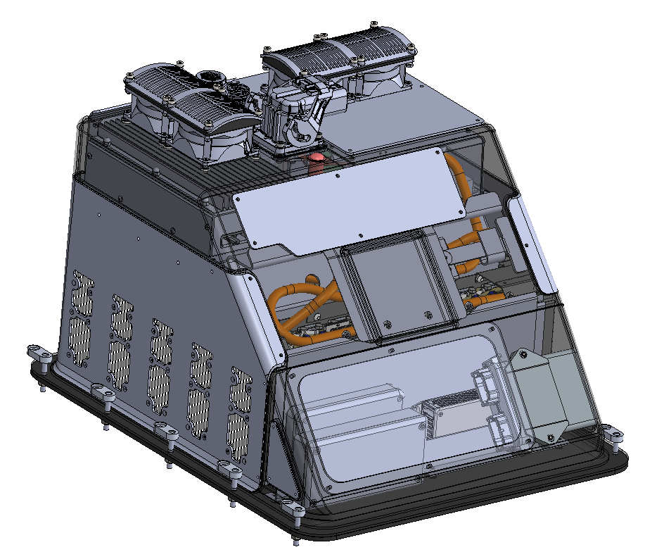

**TSAL Circuit**

Figure 4‑4 - TSAL Component Locations

## Measurement Points

### Measurement Point Specifications

|  |  |
| --- | --- |
| Make / Model: | Tenma 76-1658 |
| Voltage Rating: | 600V |
| Datasheet: | [Datasheet](http://www.farnell.com/datasheets/2168397.pdf?_ga=2.38859175.589244376.1545586508-2113163417.1488289129) |

Table 4‑2 - Measurement Point Specifications

### Measurement Point Location

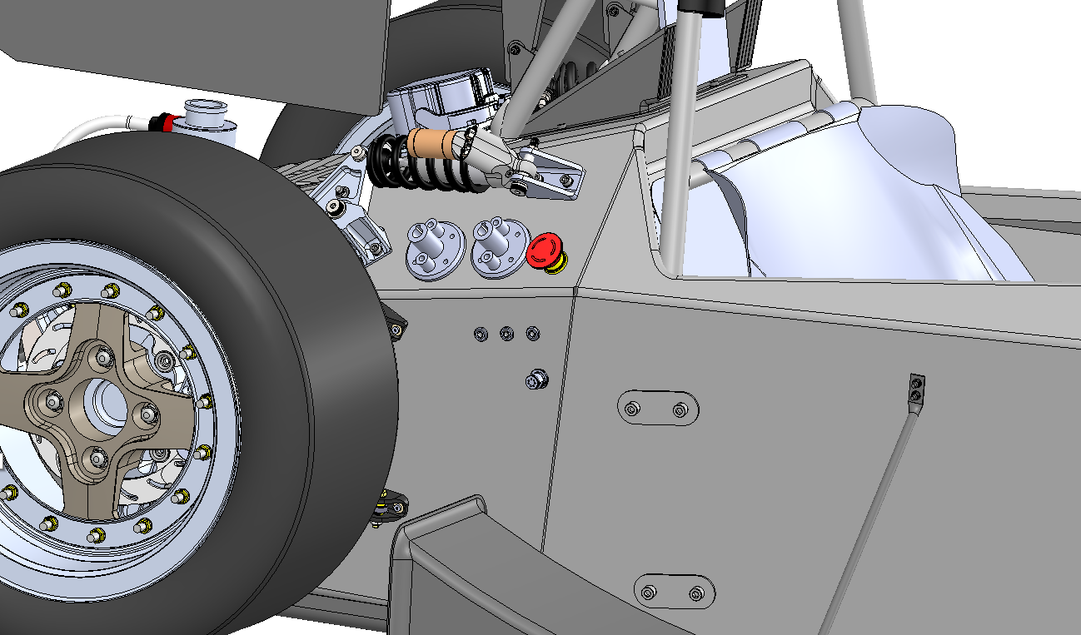

**TSMP**

Figure 4‑5 - Measurement Point Location

### Measurement Point Protection

The backing of the TSMPs as well as the GLV measuring point Is protected by a 3D printed housing. It is designed in such a way that the through air requirements are met for the distance between HV+, HV-, and GLV. Additionally, walls are printed between each contact to ensure accidental touching between contacts or fingers does not occur. On the front of the TSMP’s a cover has been 3D printed to ensure that accidental touching cannot occur and to prevent water ingress. Please see below for the front and back covers.

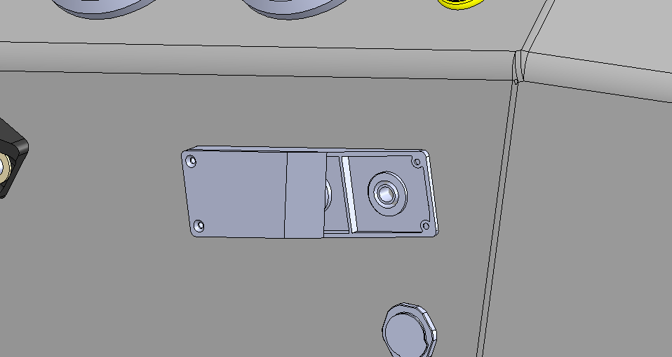

Figure 4‑6 - TSMP Protection Cover

### TSMP Protection Resistor

|  |  |
| --- | --- |
| Make / Model: | TE Connectivity/HSA2515KE |
| Resistance: | 15,000Ω |
| Voltage Rating: | 400V |
| Power Rating: | 12.5W |
| Datasheet: | [Datasheet](https://www.te.com/commerce/DocumentDelivery/DDEController?Action=srchrtrv&DocNm=1773035&DocType=DS&DocLang=English) |

Table 4‑3 - TSMP Protection Resistor Specifications

Note, the resistors are not heatsunk, however they are rated at 12.5W continuously without the heatsink which is above the required 10.6W for 400VDC with a 15Kohm resistor

### TSMP Protection Resistor Location

TSMP resistors are located in the HVIB enclosure.

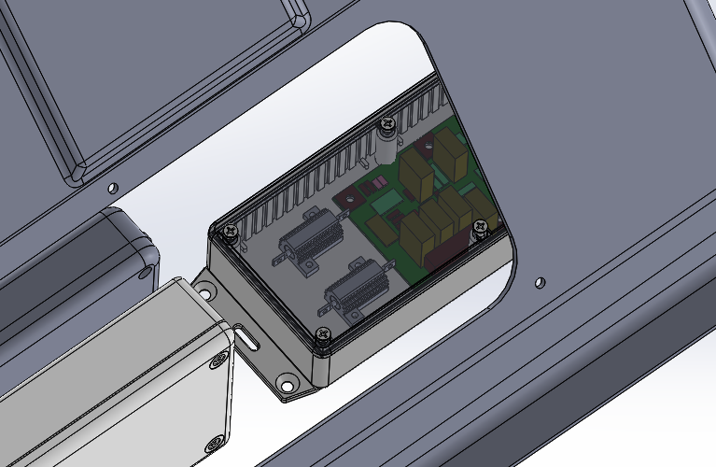

**TSMP RESISTORS**

Figure 4‑7 - TSMP Protection Resistor Location

### TSMP Demonstration (Located on HVIB)

Discharge Resistance Value

1. Power down tractive system using the TSMS
2. Confirm that the TSAL is indicating that the AIR’s are open
3. Measure the resistance at the TSMP
4. Subtract 25kΩ

Current Limit Resistor Value

1. Power down tractive system using the TSMS
2. Confirm that the TSAL is indicating that the AIR’s are open and that there is no HV present.
3. Measure the resistance at the TSMP
4. Subtract 2.2kΩ and divide by 2 This will give the value of the TSMP resistors since they will be in series with the discharge resistor when the discharge circuit is active.

TS Voltage (Confirm Off)

1. Turn off TSMS and GLVMS
2. Confirm the TSAL is indicating that the AIR’s are open
3. Measure the voltage at the TSMP

TS Voltage (Confirm On)

1. Turn on TSMS and GLVMS
2. Confirm HVD is in place
3. Press the traction system start button on the dash
4. Confirm the TSAL is indicating that the AIR’s are closed
5. Measure the voltage at the TSM

## HVD

### HVD Specifications

|  |  |
| --- | --- |
| Make / Model: | TE AMP+ Manual Service Disconnect |
| Ampacity: | 630A |
| Voltage rating: | 450V |
| Datasheet: | [Datasheet](https://www.te.com/content/dam/te-com/documents/hybrid-and-electric-mobility-solutions/global/8-1773462-2-msd.pdf) |

Table 4‑4 - HVD Specifications

### HVD Location

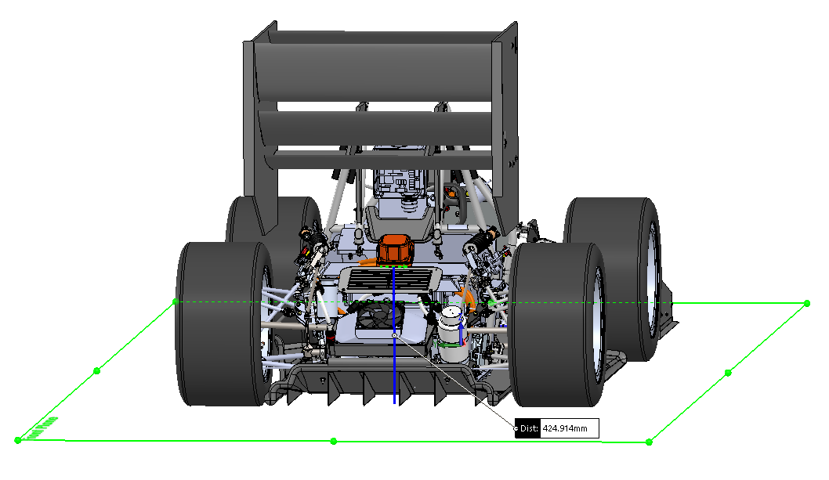

Figure 4‑8 - HVD Location

### HVD Connections

The female receptacle of the HVD is connected via ring terminals and hex bolts. The HVD is mounted on the monocoque of the vehicle and not on any removable body work. Additionally, a 3D printed housing will be fastened to the back of the female receptacle to protect it from water ingress and being touched by anyone. The male receptacle is just a loop that passes the connection from one side of the female connection though a fuse and out the other. It comes pre-assembled and will completely protect from water ingress. Additionally, a pilot line through the connector will ensure that upon opening the circuit the AIR’s are decoupled so that high voltage cannot be present at the connection when the HVD is removed.

### HVD Demonstration

To remove the HVD Lift the two-stage lever assisted black latch on the HVD and pull on the connector. Replace the HVD with a dummy connector to ensure the prevention of water ingress and accidental touching.

Remove the HVD if:

* Performing maintenance on the following:
  + Accumulator
  + IMD
  + Inverter
  + Any component containing high voltage in the vehicle
* Manually pushing the vehicle
* During charging
* Before technical inspection at competition
* When leaving the vehicle unattended

## Ready to Drive Sound

### RTDS Device and Control

The ready to drive signal is controlled from a half bridge output of the VCU. It is sounded before the VCU enters the ready to drive state and allows torque output.

|  |  |
| --- | --- |
| Make / Model: | Mallory Sonalert Products / ZA016LDFP1 |
| Control Voltage: | 12V |
| SPL at 2m: | 85 dBA |
| Datasheet: | [Datasheet](https://www.mspindy.com/specifications/ZA016LDFP1.pdf) |

Table 4‑5 - RTDS Specifications

### Ready to Drive Mode Demonstration

1. Set TSMS and GLVMS to ready to on position
2. Reset external circuit
3. Enter vehicle
4. Reset internal circuit
5. Press brake pedal and hold start button
6. Wait for ready to drive sound, observe light on dashboard
7. Release start button

### Discharge Circuit Component Specifications

|  |  |
| --- | --- |
| Make / Model: | TE Connectivity / HSC1003K9J |
| Resistance: | 3.9kΩ |
| Voltage: | 469V |
| Power: | 50W |
| Power @15sec: | 2.65E-12 W |
| Datasheet | [Datasheet](https://www.te.com/commerce/DocumentDelivery/DDEController?Action=srchrtrv&DocNm=1773035&DocType=DS&DocLang=English) |

Table 4‑6 - Discharge Resistor Specifications

|  |  |
| --- | --- |
| Make / Model: | Gigavac PNC113BDA |
| Contact Current Rating: | 30A |
| Contact Voltage Rating: | 1500V |
| Datasheet: | [Datasheet](http://www.gigavac.com/sites/default/files/catalog/spec_sheet/pnc113.pdf) |

Table 4‑7 - Discharge Relay Specifications

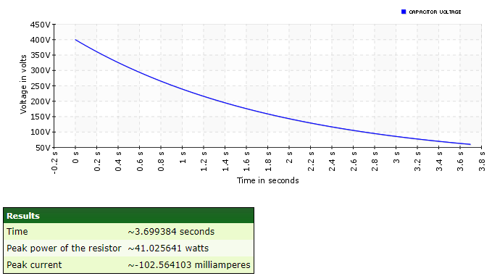

The discharge circuit is rated to 50W without a heatsink which is below the peak power of the discharge circuit of 41W. Thus, the discharge circuit can handle the discharge current continuously.

The motor drive has internal capacitance of 500 uF and the DC/DC converter has input capacitance of 0.8uF. The discharge voltage is shown above using the system voltage of 399V and the discharge resistance of 3900 Ω. The Inverter takes 3.6s to discharge to under 60V. The DC/DC converter will be discharged though the High Voltage Interlock Board’s current regulator. The current regulator draws 15ma of current continuously until it is under 10V. This equates to a discharge from 400V to 60V of 18ms (340*0.0000008/0.015 = 0.018s).

### Discharge Circuit Location

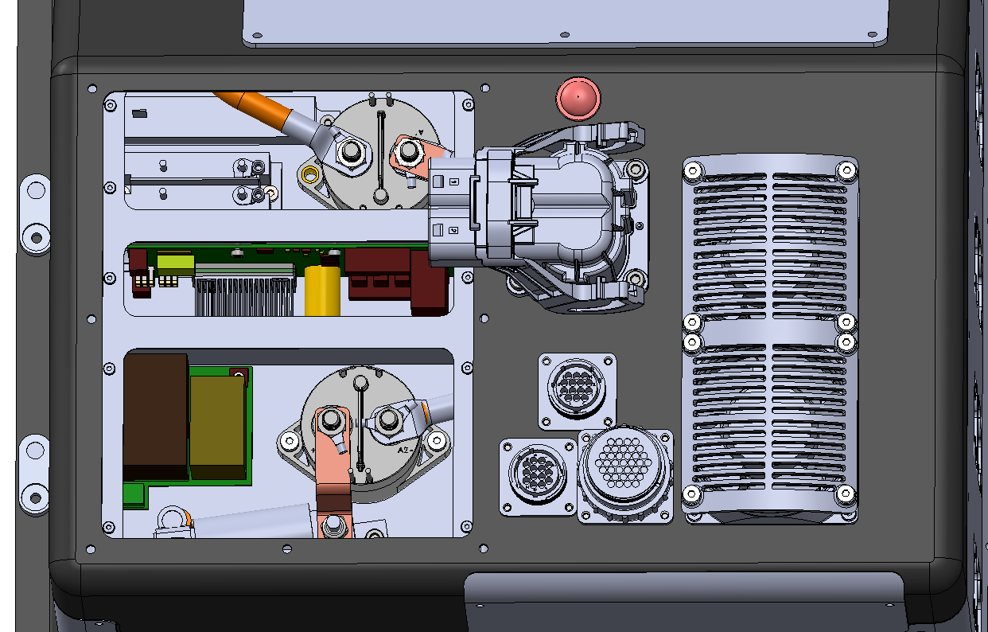

**Discharge Relay**

Figure 4‑9 - Discharge Circuit Component Locations

### Discharge Circuit Control

The discharge is enabled any time the AIR’s are open. The NC contact on the AIR’s is connected to the coil of a second NC relay to invert the logic. Finally, from the second NC contact the discharge relay is energized when the AIR’s are turned on to disable the discharge circuit, and de-energized when the AIR’s are turned off, which enables the discharge circuit. The discharge is connected to the drive negative through the auxiliary connector such that it can still operate when the HVD is connected.

### Discharge Circuit Demonstration

1. Power down vehicle using the Tractive System Master Switch
2. Wait 5 seconds
3. Measure voltage at Tractive System Measuring Point via the procedure in the TSMP section.

# 

# Accumulator

## Accumulator Schematic

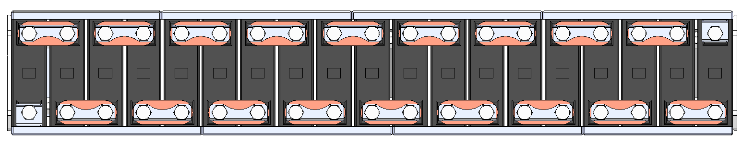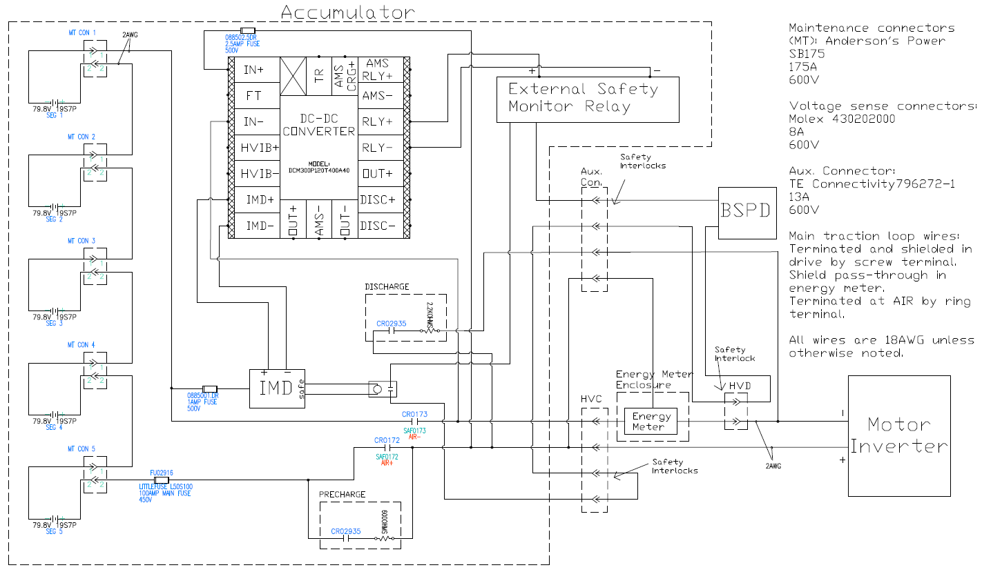

Cell Connection Detail

Figure 5‑1 - Accumulator Schematics

## 

Note that although the discharge circuit is in the accumulator, it has its negative end connected to the negative pole of the motor inverter directly, this will allow the capacitance in the motor controller to discharge fully even with the HVD removed. The capacitance in the DC/DC converter would be discharged through the HV detection circuit in this scenario.

## Cells

### Cell Specifications

|  |  |
| --- | --- |
| Cell Make / Model / Style: | LG HG2 - cylindrical |
| Cell nominal capacity: | 2.858Ah |
| Maximum Voltage: | 4.2 V |
| Nominal Voltage: | 3.6V |
| Minimum Voltage: | 2.5V |
| Maximum output current: | 95A for 0.5s |
| Maximum continuous output current: | 20A – Tested by LG for 30A without issue |
| Maximum charging current: | 4A |
| Maximum Cell Temperature (discharging) | 60°C |
| Maximum Cell Temperature (charging) | 45°C |
| Cell chemistry: | Li[NiMnCo]O2 (H-NMC) / Graphite + SiO |

Table 5‑1 - Cell Specifications

### Cell Electrical Configuration

The battery pack is arranged in a 7P95S configuration. The pack is broken into 5 segments of 7P19S connected in series. Each segment was created through use of 19 x 7P1S modules from Energus Power Solutions connected in series.

### Cell Connections

The individual cells are packaged into modules by Energus Power Solutions. The specific connections between the Energus modules can be found below. The modules are connected using busbars with a cross sectional area of 44.45 mm^2 and ampacity of 150 A. Positive locking is achieved using tab washers on the aluminum bolts as shown in the rendering. Once all bolts on each busbar are torqued down, the tabs are bent up around the bolt head to prevent rotation and ensure a retained connection between the cells and the busbar.

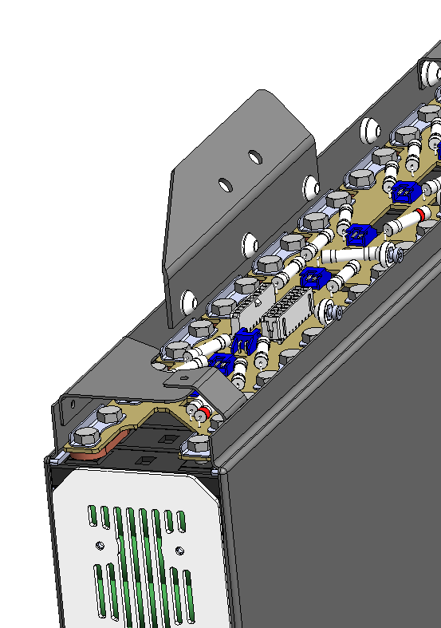 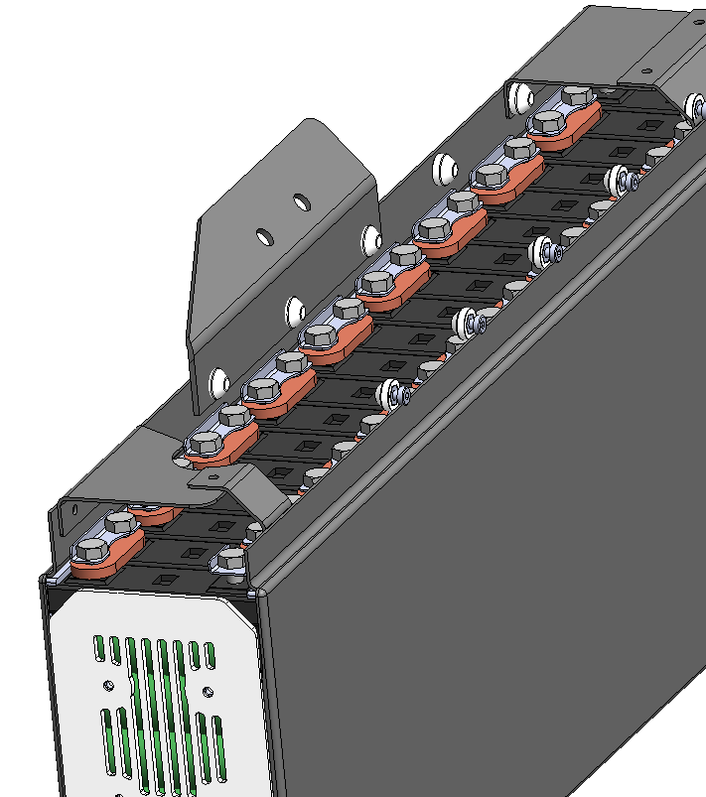

Figure 5‑2 - Cell Connection Detail

### Parallel Cell Overcurrent Protection

Each cell in a parallel series is connected to its segment’s bus bar in series as denoted in the cell configuration. Each one of the parallel segments represents one of the Energus 7P1S modules. The cells in the Energus modules are individually as shown below in the fuse blow time chart. Each cell is connected to a module busbar with a 45A fusible link as shown in Figure 6-4. This gives each parallel segment a continuous rating of 315A. A fast-acting LittleFuse L50S100 fuse will be present in line with the accumulator to blow before the Energus fuses are able to blow as shown below. For a representation of the blow time on the master fuse vs. the blow time of the Energus modules see the graph titled Blow Time vs Accumulator Current below.

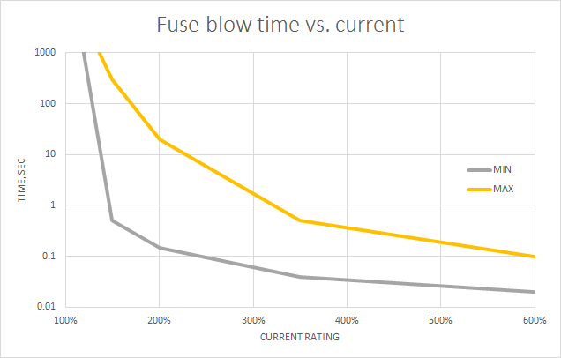

Figure 5‑3 – Fuse blow time vs. current



Figure 5‑4 – Energus cell fuse

Figure 5‑5 – Blow Time vs Accumulator Current

### Cell Mounting

The Energus battery modules come as a set of seven 18650 cells encased on the top and on the sides by a structural UL94-V0 plastic. This layer of structural plastic ensures that the cells do not contact the surrounding structure. The cell modules are placed vertically in segments and connected by bus bars. Each segment acts as a rail system which slides into the accumulator. Modules are retained to each segment using side walls and clamping force. A 3D printed, ABS plastic racking system is bonded to a glass and carbon fiber reinforced polymer tray (glass fiber is used for insulation). The racking system and walls of the tray retain the cells both vertically and laterally. Longitudinal retention is attained through clamping features, glass and carbon fiber reinforced polymer parts, fastened to the bottom corners and top center of the segment rail. A total of 10, M3 fasteners will be used. PEEK plastic fasteners will be used as they offer sufficient strength properties, and dielectric breakdown properties that are acceptable to the tractive system voltage, in the case of a falling fastener.

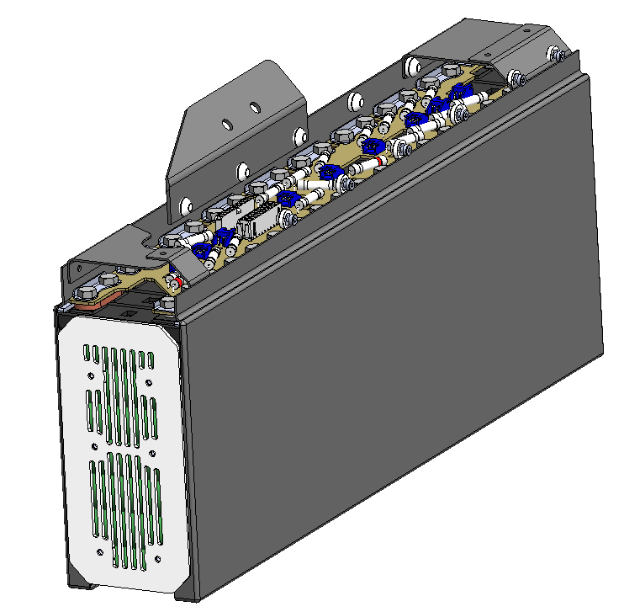

Figure 5‑6 - Cell Mounting in Accumulator

## Segments

### Segment Specifications

|  |  |
| --- | --- |
| # of Segments: | 5 |
| Cells per segment: | 19 Energus Modules (133 Cells) |
| Cell configuration in segment: | 7P19S |
| Energy in segment: | 6.0MJ / 1.596KWh  ~~5.03MJ / 1.40 kWh (integral)~~ |

Table 5‑2 - Segment Specifications

Energy in segment calculation:

4.2V * 3.000Ah * 133 cells * 3.6 (MJ/kWH) = 6.0 MJ

~~Energy in segment calculation:~~

~~Energy in a cell segment is equivalent to the integral of power vs time of each segment. Since voltage of the segment will drop as the cells become discharged the power output will drop over time. The voltage vs time graph for various currents of an LGHG2 cell is as follows:~~

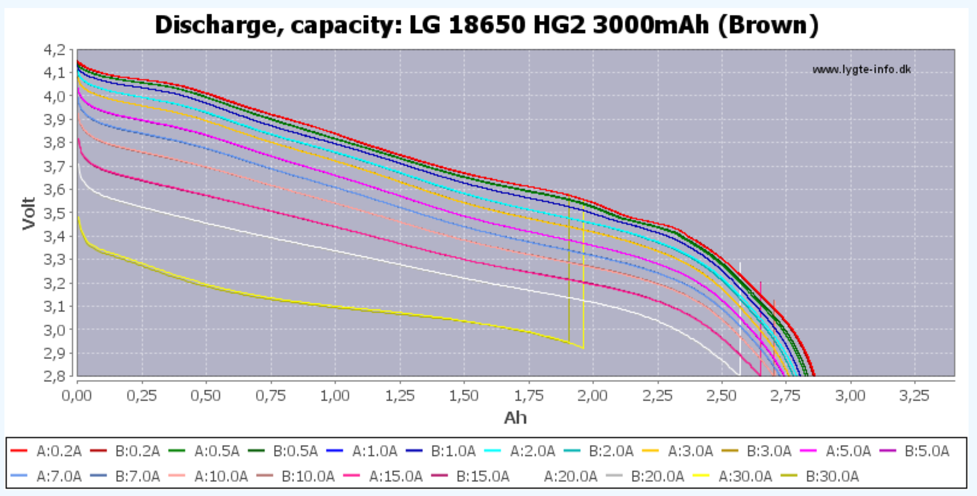

~~The integral of this curve multiplied by current yields the area under the curve and hence energy in one cell. Each cell has 10499Wh of energy in it as measured by the 0.2A discharge curve (most conservative). Multiplying this value by the 133 cells in each segment yields 1.396kWh which is equivalent to 5.026 MJ and under the competition limit.~~

~~An even more conservative calculation would use the maximum voltage of each cell multiplied by its nominal capacity of 2.858Ah (as shown in the graph above). This calculation is as follows: 4.2v * 2.858Ah * 133cells = 1.596KWh = 5.75MJ which is also under the competition limit.~~

Data Source:

<https://lygte-info.dk/review/batteries2012/LG%2018650%20HG2%203000mAh%20(Brown)%20UK.html>

### Segment Physical Isolation

The modules are packaged into five segments of 19 modules, separated by composite walls. Each composite wall is made of carbon fiber and is insulated with glass fiber. When packaged into their sections, the only visible surface of each battery is the sidewalls. The battery box is safe from dropped tools because it is completely enclosed except for cooling vents and access hatches, which are covered by filters with <3mm of space through which a tool tip could protrude. Furthermore, the battery modules are located under all GLV components and cooling fans, whose footprint completely cover the top projected area of the batteries, protecting from tools and has a fiberglass insulated barrier between the fans and GLV components. The top of the segments are covered by flanges made from glass fiber reinforced polymer.

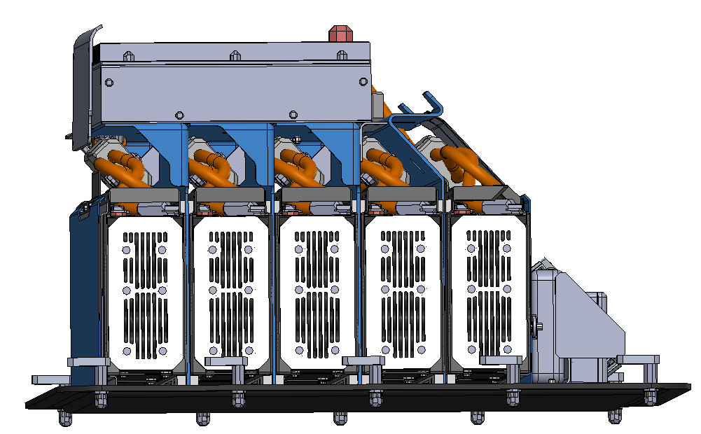

GFRP Flanges

Figure 5‑7 – Accumulator CAD of segments

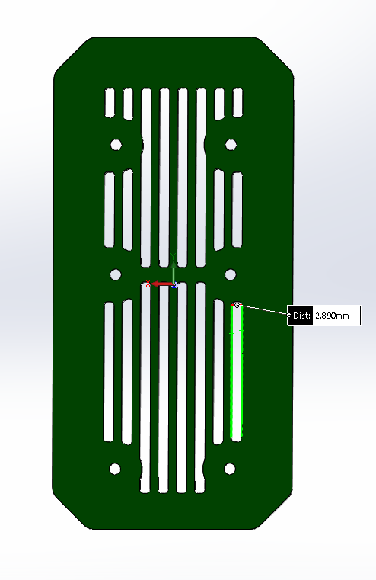

Figure 5‑8 – Intake/Gore-tex barrier to accumulator

### Maintenance Plugs

Andersons Power SB175 were used as maintenance plugs in the accumulator. The maintenance plugs were given their own housing just above the fans in the accumulator container to so that a person cannot accidently touch the accumulator cells when disconnecting the maintenance plugs. The flange for the maintenance plug access hatch covers all other hatches so that a user is mechanically guided to disconnect the maintenance plugs before opening any other hatch on the accumulator. Each plug and receptacle receives its own channel above its segment so that it cannot be accidently plugged into an incorrect connector. As shown in the rendering below each maintenance plug acts on both the positive and negative lead of each segment in the accumulator to connect all segments in a series configuration.

|  |  |
| --- | --- |
| Make / Model: | Andersons Power SB175 |
| Ampacity: | 175A |
| Voltage: | 600V |
| Datasheet: | [Datasheet](https://www.mouser.ca/datasheet/2/22/SB175-1158160.pdf) |

Table 5‑3 - Maintenance Plug Connector Specification

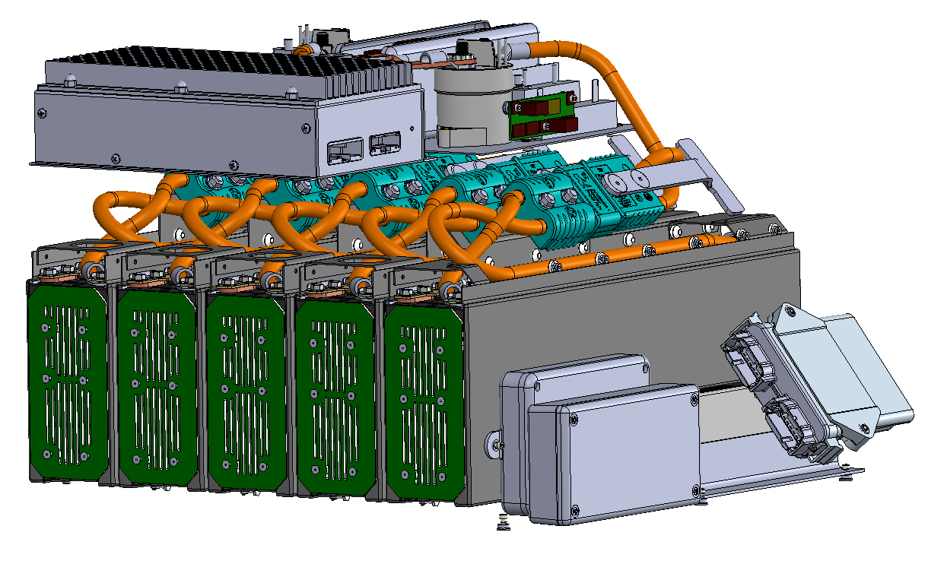

Figure 5‑9 – CAD of maintenance plugs

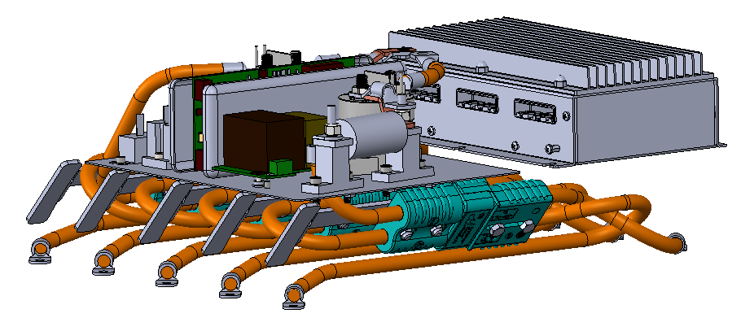 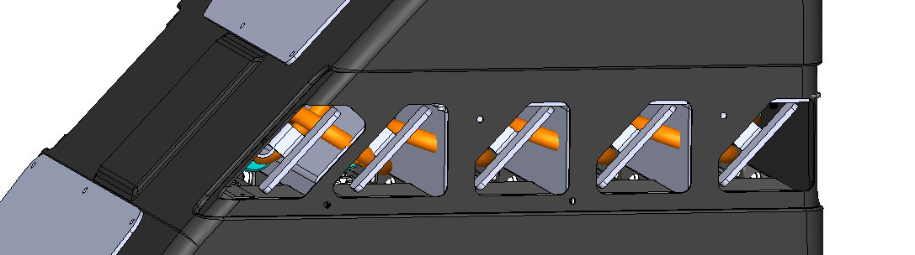

Figure 5‑10 - Maintenance Plug Locations

### Maintenance Plug Positive Locking

Andersons Power SB175 connectors satisfy the positive locking requirement through their contact retention force rating of 300lbf as clarified by a rules question.

### Maintenance Plug Unique Configuration

As shown below the maintenance plugs are designed in such a way that there is a maintenance hatch that must be removed to access the maintenance plugs. Once the hatch is removed four channels will be exposed. Each connector gets its own channel except for the front most segment in the accumulator. This channel will be shared with the segment next to it and the connectors in this channel will be specifically keyed to ensure that they cannot be inserted into the incorrect receptacle.

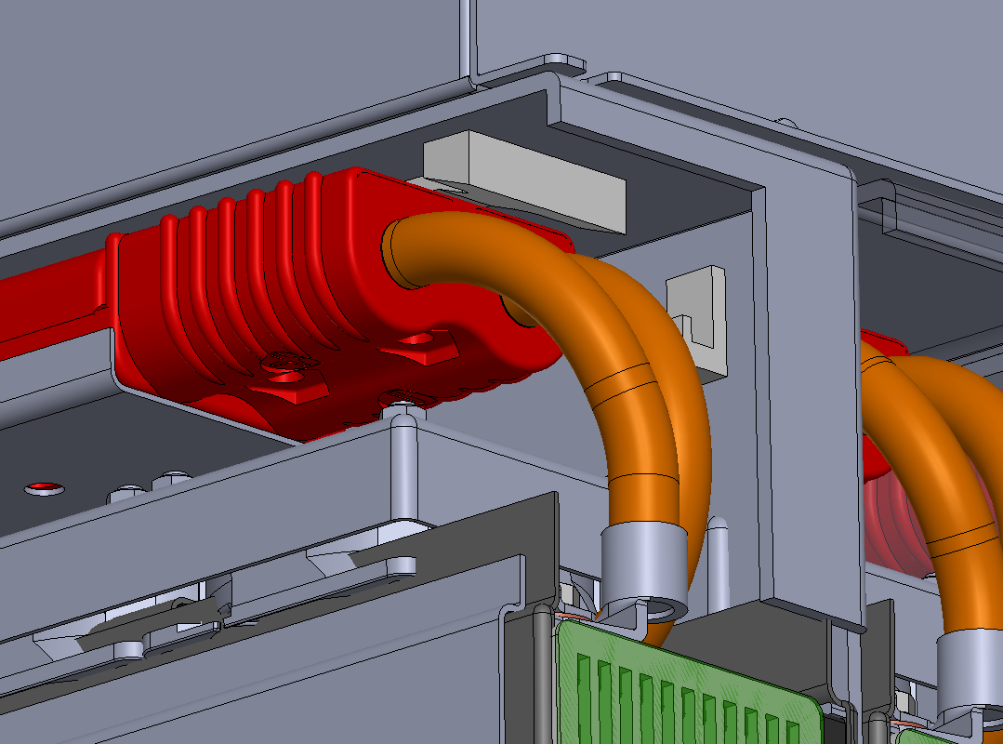

Figure 5‑11 – Maintenance plug latches

### Maintenance Plug Demonstration

Maintenance plugs can only be accessed by removing the maintenance plug hatch of the accumulator. When disconnecting the maintenance plugs, high voltage gloves, safety glasses, and insulated tools will be used.

1. Remove the Maintenance plug access panels
2. Remove the five smaller BMS plugs
3. Disconnect the left most connector
4. Latch the connector into its disconnected position to ensure no accidental contact
5. Repeat steps 2 and 3 for all connectors
6. Reattach the maintenance plug access panel

## Precharge Circuit

### Precharge Circuit Component Specifications

|  |  |
| --- | --- |
| Make / Model: | Ohmite/ AP101 620R J |
| Resistance: | 620Ω |
| Voltage: | 700V |
| Power: | 100W |
| Power @15sec: | 0W |
| Datasheet | [Datasheet](https://www.ohmite.com/assets/docs/acl_ap101.pdf?r=false) |

Table 5‑4 - Precharge Resistor Specifications

|  |  |
| --- | --- |
| Make / Model: | Omron / G7L-2A-X-L DC12 |
| Contact Current Rating: | 20A |
| Contact Voltage Rating: | 1000VDC |
| Datasheet: | [Datasheet](https://omronfs.omron.com/en_US/ecb/products/pdf/en-g7l_x.pdf) |

Table 5‑5 - Precharge Relay Specifications

### Precharge Circuit Location

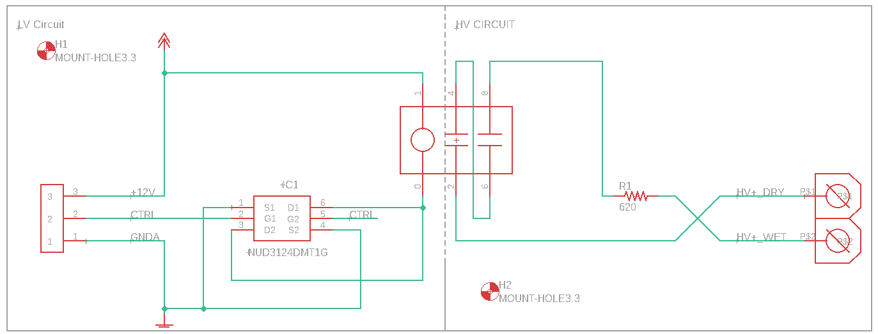

Figure 5‑12 – Precharge circuit schematic

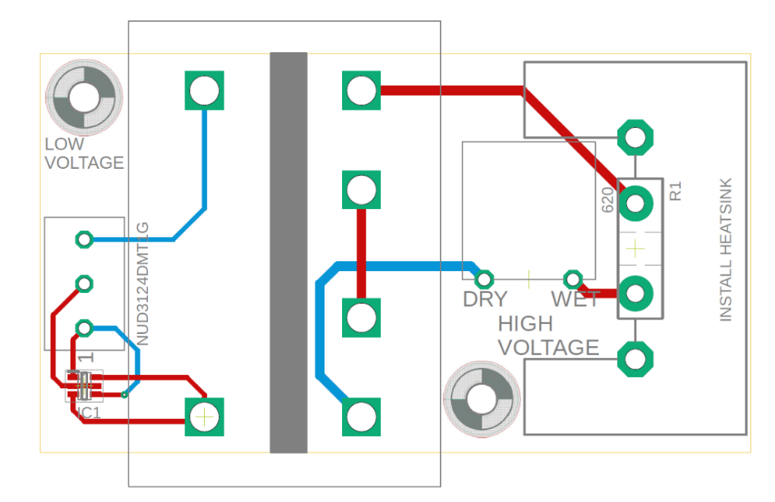

Figure 5‑13 – Precharge circuit PCB layout



**Pre-charge Relay**

Figure 5‑14 - Precharge Circuit Location

### Precharge Circuit Controls

The precharge relay is controlled by pin J2 – 21 on the inverter, with the coil power supplied from the TSMS. When the drive receives a start request over can bus the pre-charge relay is actuated to begin charging the inverter. The internal capacitance of the PM100DXR is approximately 500uF, and the precharge resistor is 620ohms. This gives a time constant of 0.3 seconds, assuming the inverter will be charged to 95% within three-time constants, this gives a pre charge time of 0.9 seconds.

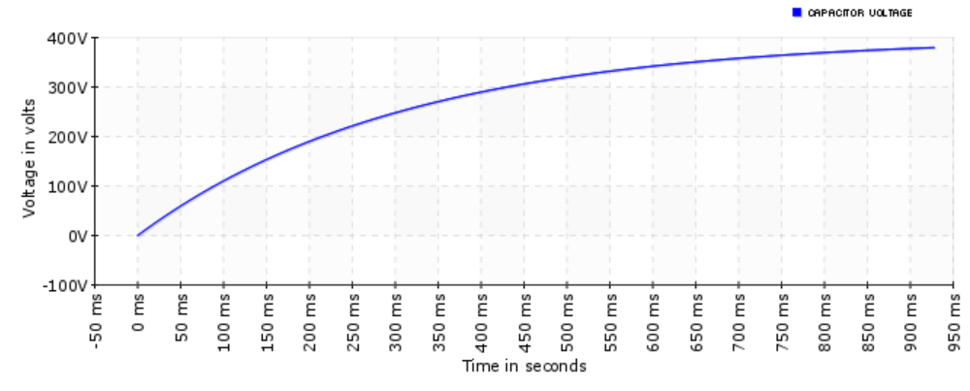

Figure 5‑15 – Precharge voltage vs. time

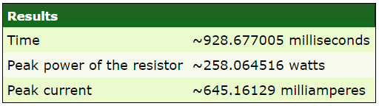

Figure 5‑16 – Precharge circuit specifications

The system can determine if the vehicle is done pre-charging with the vehicle state machine of the PM100DXR. Charge completion is determined from the following set of steps taken from page 49 of the PM100DXR manual:

The following is brief description of the pre-charge sequence. Turn-on the PRE_CHG output if Vdc has not exceeded VIN_MAX. Otherwise, set VDC_OOR_HI fault and go to the FAULT state.

1. If all the following conditions are true: Vdc stops rising by less than PRECHARGE_RATE V/s Vdc is greater than VIN_MIN, Vdc is less than VIN_MAX Time has not exceeded 1 second Then do the following: Engage the MAIN_OUT output Turn-off the PRE_CHG output Go to the 30ms delay.

2. If total pre-charge time exceeds 1 second then: If the DC BUS is greater than VIN_MAX:

* Turn the PRE_CHG output off
* Declare VDC_ OOR_HI fault. If the DC BUS is less than VIN_MIN:
* Turn the PRE_CHG output off
* Declare VDC_ OOR_LOW fault If Vdc is still rising by more than or equal to PRECHARGE_RATE V/s
* Turn off the PRECHARGE_OUT output
* Declare PRECHARGE_ TIMEOUT fault

3. Delay 30ms.

4. Measure Vdc. If Vdc is above VIN_MAX, declare VDC_OOR_HI fault. If VDC is below VIN_MIN, declare VDC_OOR_LO fault.

5. Delay 15ms.

6. Take another measurement of Vdc. If Vdc is above VIN_MAX, declare VDC_OOR_HI fault. If VDC is below VIN_MIN, declare VDC_OOR_LO fault.

7. Verify that voltage is within VDC_MATCH_RANGE_THRESHOLD of the first measurement. If not, declare VDC_DATA_MISMATCH fault.

## BMS

### BMS Specifications

The Orion BMS 2 has been selected for use as a BMS. The Orion BMS 2 is a pre-packaged solution that offers galvanic isolation between the GLV and TS busses. The Orion BMS 2 datasheet can be found [here](http://www.orionbms.com/downloads/documents/orionbms2_specifications.pdf).

The Orion BMS 2 has the following Isolation features:

* Cell taps isolated from input power supply, chassis and I/O
* 2.5kV isolation between each connector of cell taps
* Isolation allows for use of in-pack safety disconnects and fuses
* High voltage isolation fault detection circuit to monitor the breakdown of wire insulation

In addition to the isolation provided by the unit, five connectors which are bonded to the top of the cell segments are used to provide isolation in addition to the maintenance plugs. These connectors are unplugged before disconnecting the maintenance plugs. A picture of the five sets of connectors is shown below:

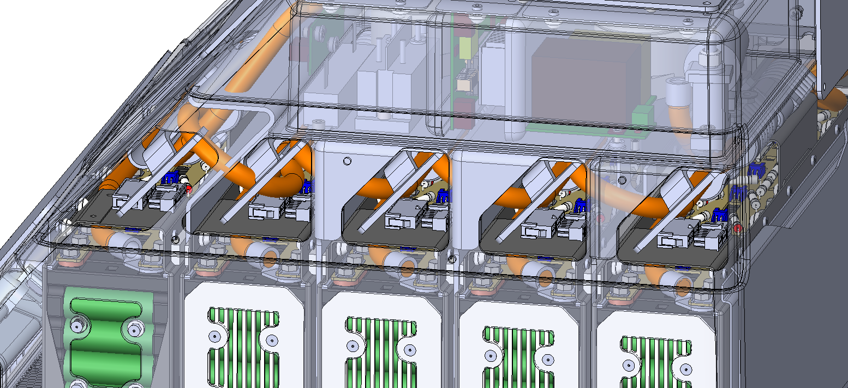

The make and model of these plugs are listed below:

|  |  |
| --- | --- |
| Make / Model: | Molex / 430202000 |
| Ampacity: | 8A (CSA) |
| Voltage: | 600V (CSA) |
| Datasheet: | [Datasheet](https://www.molex.com/pdm_docs/ps/PS-43045.pdf) |

### Temperature Sensors

|  |  |
| --- | --- |
| Make / Model: | Texas Instruments LM 135 |
| Accuracy of sensor: | 1°C when in operating range of –20C to 60C |
| Datasheet: | [Datasheet](http://www.ti.com/lit/ds/symlink/lm135.pdf) |
| # of sensors: | 40 |
| % of cells sensed: | 42% |

Table 5‑6 - Temperature Sensor Specifications

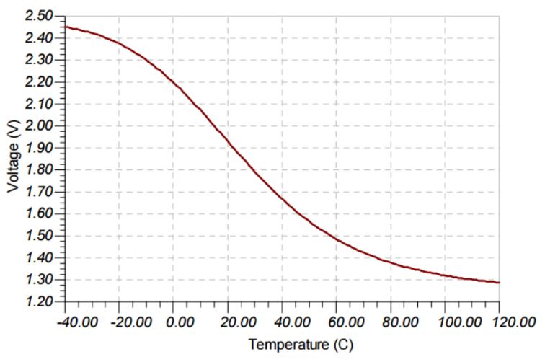

Figure 5‑17 – Temperature Sensor Output

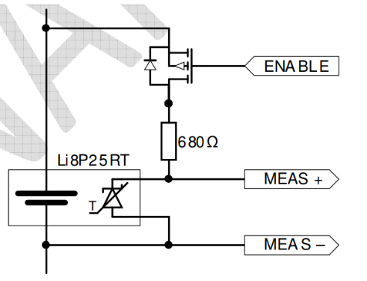

Figure 5‑18 – Temperature Sensor Configuration

### Temperature Sensor Location

The temperature sensors are directly built into the modules purchased from Energus. The temperature sensors are directly mounted to the negative terminals of each cell and are OR’d together to provide the highest temperature via to analog pins on the outside of each module. An image outlining this connection is shown below which is representative of the connection type, but not our specific modules.

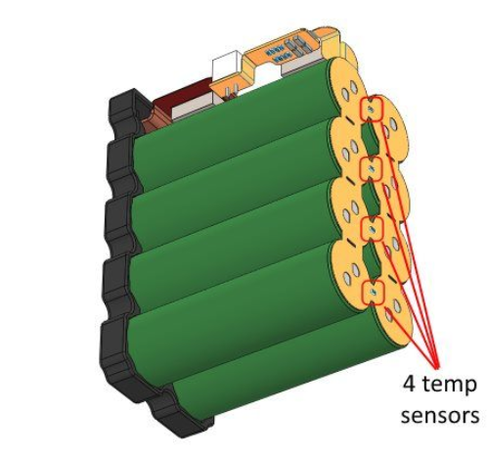

Figure 5‑19 - Location of Temperature Sensors

### BMS Voltage Sense Leads

The voltage sense leads are attached to the cells via a M5 bolt placed on top of the busbar connection to each parallel string of cells. The M5 bolt will clamp the busbar and voltage sense lead together and be positively retained via a tab washer. See below for a view of this connection.

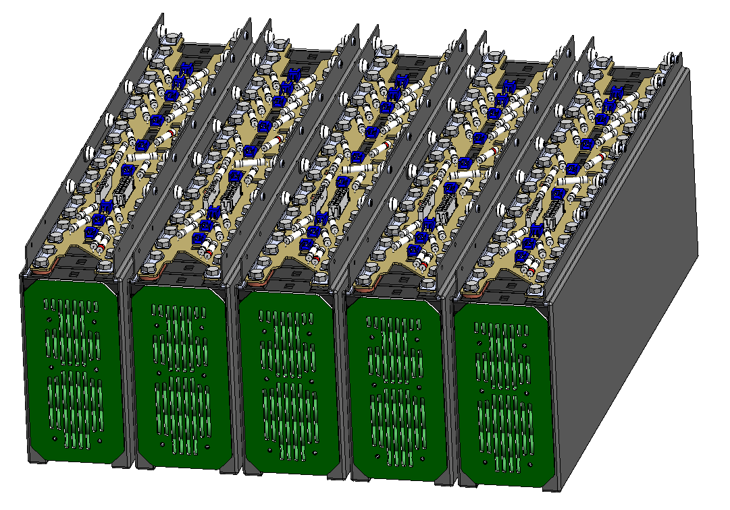

Figure 5‑20 – Voltage Sense Leads

### BMS Voltage Sense Lead Overcurrent Protection

The Voltage Sense leads are over current protected by an in-line axial fuse (TR2-S505H-V-3.15-R). The fuses are placed on the cell segment boards above the cells which make direct connections to each of the cell modules below it. The sense leads that run to the AMS are size 16AWG wire with an ampacity of 13 amps. To protect the sense lead the mentioned 3.15 amp fuse was used. It is rated for 400VDC and 600VAC.

### BMS Limits

|  |  |
| --- | --- |
| Max Cell Voltage: | 4.2V - 0.1mV (for error) – 0.2mV (for FOS) |
| Min Cell Voltage: | 2.5V - 0.1mV (for error) + 0.2mV (for FOS) |
| Max Temperature: | 59°C (for discharge) 49°C (for charging) |
| Min Temperature: | -19°C (for discharge) 1°C (for charging) |

Table 5‑7 - BMS Setpoints

### BMS Location

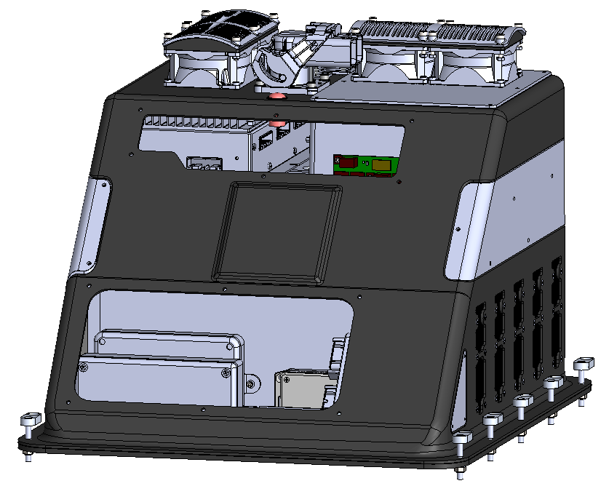

**BMS**

**Temperature Module**

Figure 5‑21 - BMS Location

## AIR

### AIR Specifications

|  |  |
| --- | --- |
| Make / Model: | Gigavac / GV200MAC-1 |
| Contact Current: | 500A |
| Contact Voltage: | 800V |
| Datasheet: | [Datasheet](http://www.gigavac.com/sites/default/files/catalog/spec_sheet/gv200.pdf) |

Table 5‑8- AIR Specifications

This model of the GV200 series has a normally closed auxiliary contact. If normally open functionality is required, the output from the auxiliary contact is connected to the coil of a form C relay to invert the output.

## Accumulator Indicator

### Accumulator Indicator Schematic

The accumulator light output comes from the ACC light terminals located on the HVIB. It is activated by the same sensing lines that turn on the TSAL when the accumulator is connected to the vehicle. The HVIB is powered directly from a fused line on the DC/DC converter and will have power whenever the AIR’s on the vehicle are closed and hense the Accumulator Indicator will illuminate. Further documentation on the HVIB is located at the end of the document in section 8.4.2.

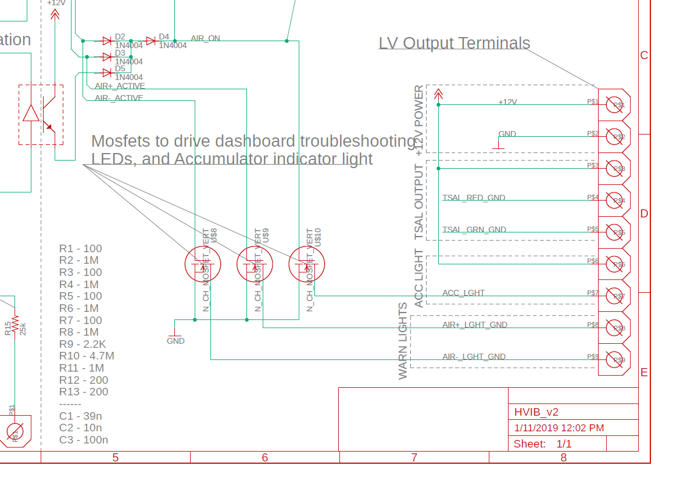

Figure 5‑22 - Accumulator Indicator Light Mosfet Output

The accumulator indicator is driven by the same circuit as the TSAL circuit. Instead of driving a clock signal however, it is driven by a single MOSFET which turns on an LED on the accumulator container.

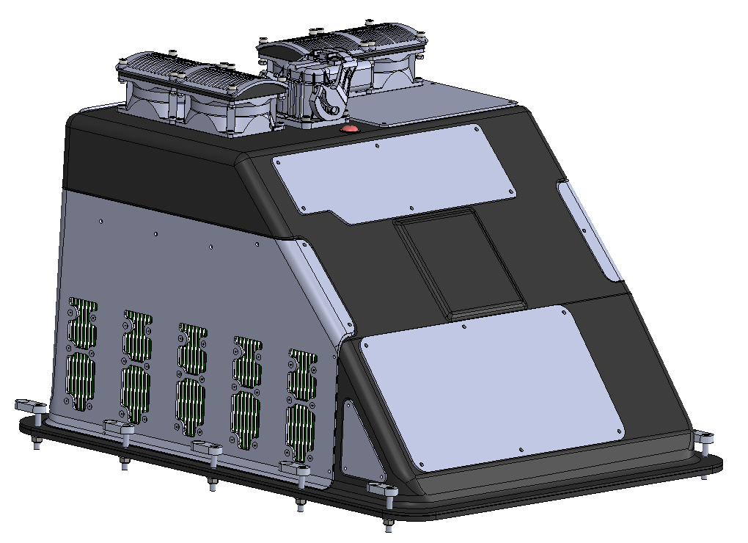

**Indicator Light**

Figure 5‑23 - Schematic of Accumulator Indication

## Mechanical

### Accumulator Enclosure

Each cell module is insulated from the accumulator container by means of a structural UL94 V-0 plastic that encases the cells.

The accumulator container, including all internal vertical walls, is made of sheets of carbon and glass fiber reinforced polymer. Each sheet contains some number of carbon fiber plies such that structural requirements are met as per the Structural Equivalency rules for the HV Enclosure. Each sheet also contains glass fiber plies such that it is insulated and rated to a dielectric breakdown greater than the voltage of the traction system. See below for insulation calculations:

*Dielectric strength of fiberglass:*  ***13.5MV/m*** *(*[*datasheet*](https://drive.google.com/open?id=1kLH3doToNu036mcdmTYKnn8lfAcP8Pud))

*Critical thickness = 400V/13.5MV/m = 0.00002962962m = 0.002mm*

*Finishing glass fabric has thickness between 0.1-0.2mm, meaning panels will be insulated with a factor of safety of 100-200 for dielectric breakdown.*

Each sheet is infused with CELLOBOND Phenolic J2027X-1 , a phenolic resin provided to the team by Hexion (Three Data Sheets: [datasheet 1](https://drive.google.com/open?id=1bmHHycyS4ZwQuf1h7BWf1EhJYrgo36Sc), [datasheet 2](https://drive.google.com/open?id=1PL3tXj9icvJRjIpY025Q8dtOINuSKbNf), [datasheet 3](https://drive.google.com/open?id=1pUCdSTYopUEqQSZTk1JNlxZ84TQ1-z92)), in order to be flame retardant to FAR25. Phenolic resin is not electrically conductive. Furthermore, the extremely fine weave of the glass plies combined with the fact that it is encased in the resin means that panel will remain insulated even if it is scratched or otherwise damaged.

### AIR and Fuse Separation

Each Energus battery module is a set of seven 18650 cells encased on the top and on the sides by a structural UL94-V0 plastic. This layer of structural plastic ensures that the cells do not come into contact with the accumulator container, and also create separation between the cells and the AIR and/or fuses. The AIR and fuses are also situated above a layer of plastic fans that are further encased in plastic and thus create another insulating barrier between the cells.



Figure 5‑24 - AIR and Fuse Separation

## Charging

### Charger Specifications

|  |  |
| --- | --- |
| Make / Model: | Siemens Valeo - EV250035 |
| Power: | 3.5KW |
| Output Voltage: | 430V |
| Output Current: | 12A |
| Input Voltage: | 85 – 275VAC (single phase) |
| Input Current: | 16A |
| Datasheet: | [Datasheet](https://drive.google.com/open?id=1h88dv2jxBet2wmbJTwUzt_MTbj3JhFbc) |

Table 5‑9 - Charger Specifications

### Charging Shutdown Circuit



Figure 5‑25 - Charging Shutdown Circuit Schematic

### Charging TS Circuit

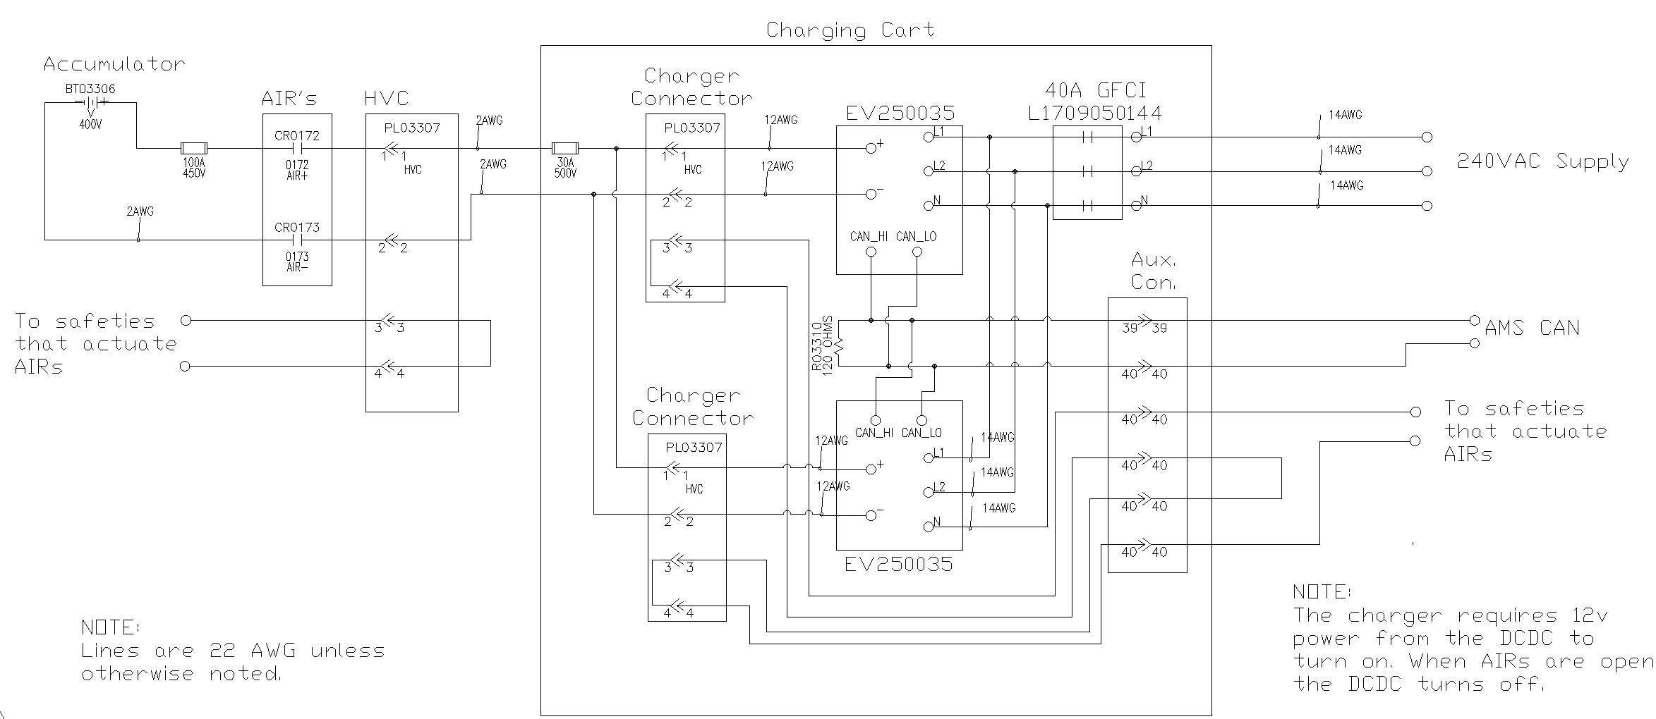

Figure 5‑26 - Charging TS Schematic

### Charger TS Connection Interlock

The main TS connector for our accumulator has a pilot line interlock integrated into it. If this pilot line is broken or any other safety faults occur, the AIR’s are opened. If the AIR’s are open the DC/DC loses power and the charger is put into standby move (no power output).

### Charger Control

Once the low voltage connector is plugged into the accumulator from the charging cart, the BMS will boot up in charging mode. While in charging mode the accumulator has an interlock connection the charger, which will shut the charger off in the event of the following conditions:

* Overcurrent
* Over-temperature
* Under-temperature
* Over-voltage
* Under-voltage
* General fault

If the AMS detects any of the previous faults, it will output an unsafe status signal to the charger which will shut it off.

### Charger Demonstration

1. Ensure the charger is disconnected from AC power.
2. Ensure service cap is installed on the accumulator’s TSMP connector.
3. Connect low voltage connector to the charger harness.
4. Connect high voltage connector to the charger harness.

Ensure that the accumulator indicator light is red to indicate that the AIR’s are shut. Once the charger is connected properly it will have output current displayed on an LCD screen located on the front of the charger.

# Motor Controller

## Controls Architecture/Torque Security

Our apps sensor provides two isolated sensor outputs which are measured by the VCU. The sensor used is a 93603603 from BEI Sensors. [Datasheet](http://ecatalog.beisensors.com/Asset/ds_9360_Series.pdf). The VCU then compares the two signals which are scaled against a chart that is tuned by the team. If the two signals deviate by more than 10% of their scaled values, then the VCU signals an implausibility fault and sets the output torque of the motor controller to 0. If the signal is determined to be plausible then the requested torque is determined based on a scaled value from zero to 125 Nm.

In a short circuit scenario, the ECU will read more than 10% difference between the two sensors and signal a plausibility fault. The plausibility fault will set the torque command to 0 Nm. In an open circuit scenario, there is a pull up resistor connected to the negative slope line and a pull down resistor connected to the positive slope line that will pull both lines to a voltage corresponding to 0% throttle.

Figure 6‑1 - APPS voltage vs. position

If the vehicle detects wheel slippage than compensation torque is applied to reduce the output torque of the motor. Compensation torque can only be negative, meaning that it can only reduce the requested torque from the motor, not increase it.

The signal path for the torque command is shown in the figure below, highlighted by the red square.

The torque signal from the APPS input is internally pulled up by the VCU, and the CAN-BUS transmission from the VCU to the PM100DXR is verified by a heartbeat signal. If the heartbeat signal is lost between the VCU and the PM100DXR the output torque of the motor is set to zero.



Figure 6‑2 - Toque Control Signal Path

## Galvanic Isolation

The RMS PM100DXR HV system is isolated from the 12V power input.

# Other Items

## Energy Meter

### Energy Meter Location

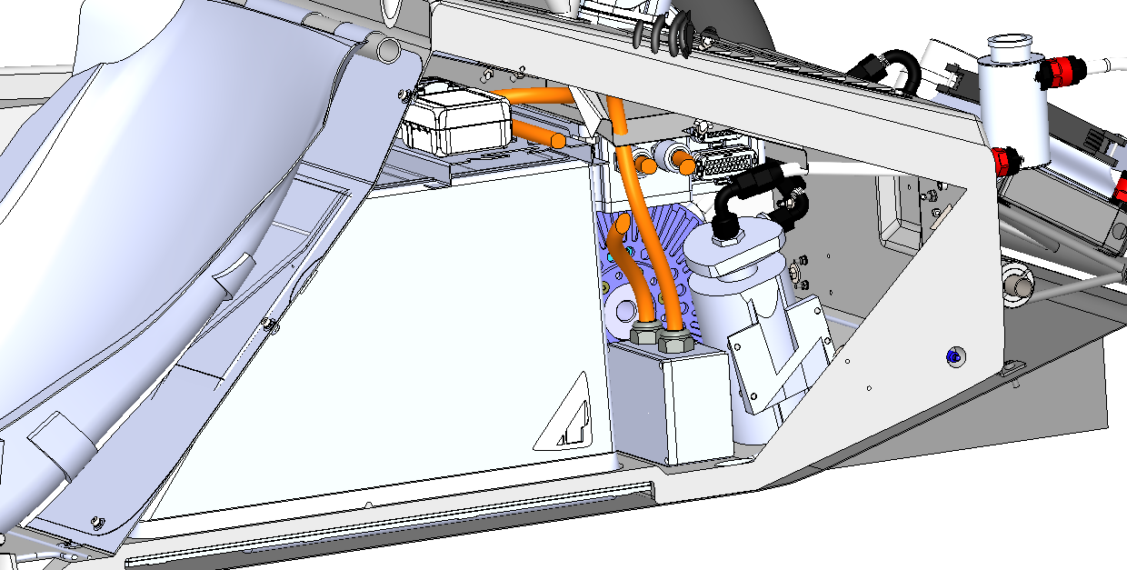

**Energy Meter**

Figure 7‑1 - Energy Meter Location

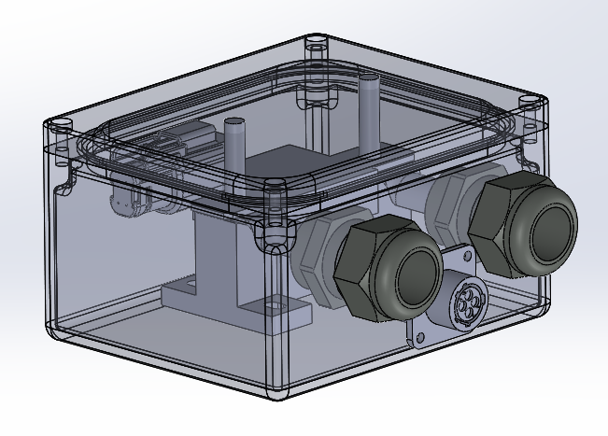

Figure 7‑2 - Energy Meter Internal Layout

### Energy Meter GLV Supply

Energy meter GLV power is supplied via the LV power distribution module (PDM) located outside of the accumulator.

### Energy Meter HV Sense

The accumulator voltage is sensed by the energy meter by using the voltage sense line coming from the auxiliary connector of the accumulator. The voltage sense line exits via the auxiliary connector, and then enters the energy meter enclosure via a wire gland. The line is fused by HVIB terminal 14 located within the accumulator.

## Firewall

### Firewall Layer Specifications

|  |  |
| --- | --- |
| Aluminum layer thickness: | 0.64mm |
| Insulating layer thickness: | 1mm |
| Insulating Material Make / Model: | Fiberglass fabric with Phenolic J2027X-1 Cellobond resin. |
| Insulating Material Datasheet: | [Datasheet](https://drive.google.com/open?id=1bmHHycyS4ZwQuf1h7BWf1EhJYrgo36Sc) 1  [Datasheet](https://drive.google.com/open?id=1PL3tXj9icvJRjIpY025Q8dtOINuSKbNf) 2  [Datasheet](https://drive.google.com/open?id=1pUCdSTYopUEqQSZTk1JNlxZ84TQ1-z92) 3 |
| Insulating layer side: | Driver Side (as per rules) |

Table 7‑1 - Firewall Specifications

### Firewall Location

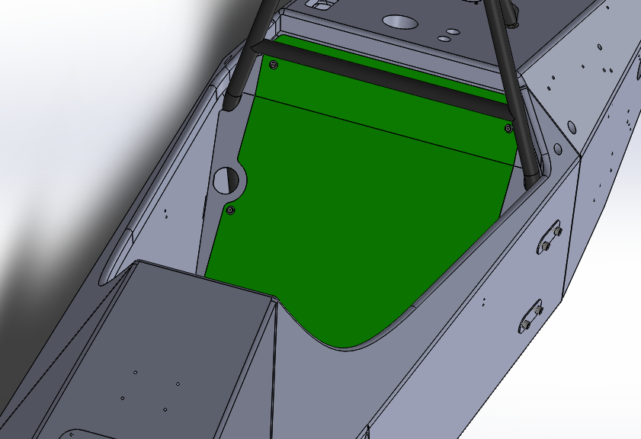

Figure 7‑3 - Firewall Location

Firewall shown in red in render above. The plate it is directly resting on, the firewall bracket, can also be considered part of the firewall. Two Grounded Low Voltage (GLV) bulkhead connections are placed on this bracket.

## Grounding

### Composite Grounding

All composites will be grounded using a highly conductive spray-on Nickel coating. This coating is offered by MG Chemicals and was tested by the team to confirm conductivity ([Datasheet](https://drive.google.com/open?id=1j6UydhLB7x66DQsj3Npc2SwzPTpcuYek)).

Product number: MG Chemicals Super Shield Nickel Epoxy Conductive Coating 841ER.

## Other Components

### DC/DC Converter

The DC/DC converter is located in the accumulator. It is fused using at 2.5A. It is de-activated during the pre-charge sequence using a set of p-channel mosfets so that the DC/DC converter does not draw current while the vehicle is in a pre charge sequence. The HV and LV side of the board are separated by 4mm using the conformal coating guidelines. Conformal coating used is 419D-340G from MG Chemicals. [Conformal coating datasheet link.](https://www.mgchemicals.com/downloads/tds/tds-419d-a.pdf) The DC/DC converter is supplied from the motor controller (dry) side of the AIR’s.

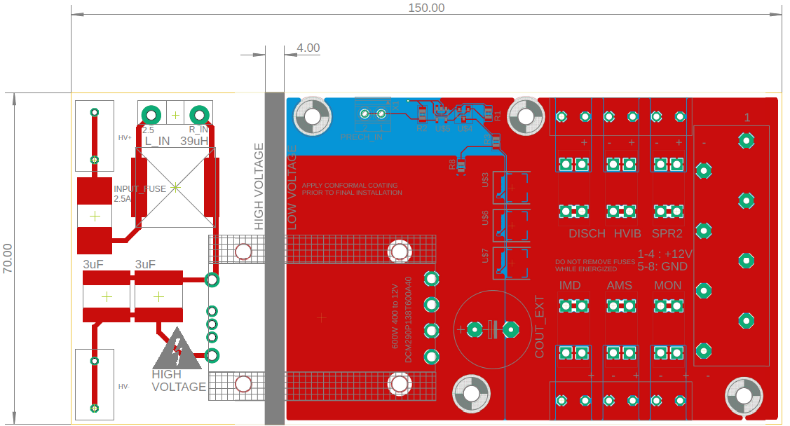

Figure 7‑4 - DC/DC Converter Board Layout

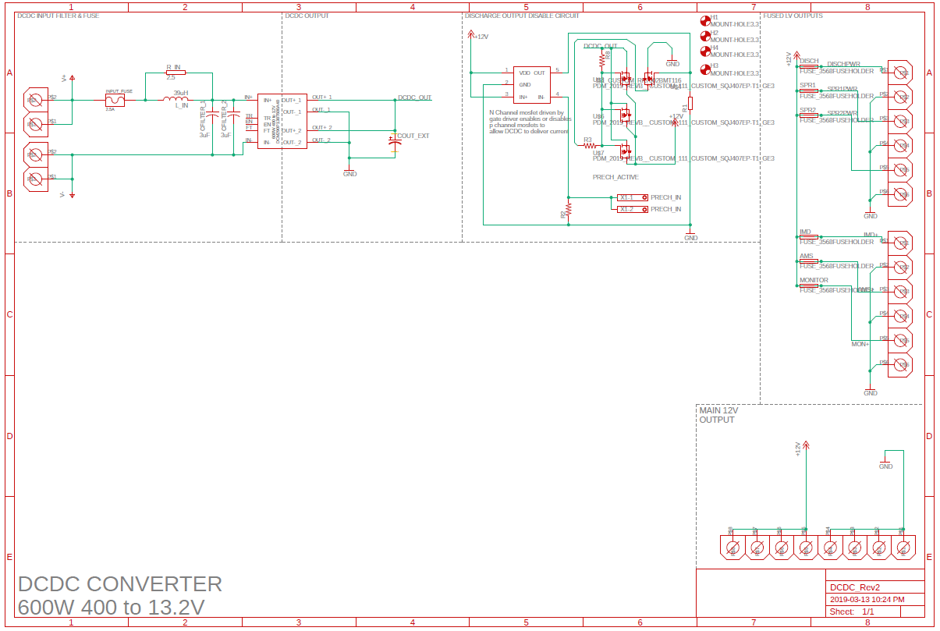

Figure 7‑5 – DC/DC Converter Schematic

Table 7‑2 – DC/DC Converter Bill of Materials

|  |  |  |  |  |  |
| --- | --- | --- | --- | --- | --- |
| Part | Part# | Qty | Manufacturer | Datasheet | Comments |
| LV Fuseholder | 3568 | 6 | Keystone Electronics | [Datasheet](http://www.keyelco.com/product-pdf.cfm?p=306) | 500V 20A |
| HV Input Terminals | 282838-2 | 2 | TE Connectivity | [Datasheet](https://www.te.com/commerce/DocumentDelivery/DDEController?Action=srchrtrv&DocNm=282838&DocType=Customer+Drawing&DocLang=English) | 13.5A, 600V |
| LV Ouptput Terminal | 1777600 | 1 | Phoenix | [Datasheet](https://media.digikey.com/pdf/Data%20Sheets/Phoenix%20Contact%20PDFs/1777600.pdf) | 41A, 1000V |
| LV Fused Terminals | 1935200 | 2 | Phoenix | [Datasheet](https://media.digikey.com/pdf/Data%20Sheets/Phoenix%20Contact%20PDFs/1935200.pdf) | 17.5A, 400V |
| DC/DC Converter | DCM290P138T600A40 | 1 | Vicor | [Datasheet](http://www.vicorpower.com/products?productType=cfg&productKey=DCM290P138T600A40) | 160 to 420V 600W |
| Input Fuse | 088502.5DR | 1 | Littlefuse | [Datasheet](https://www.digikey.ca/product-detail/en/littelfuse-inc/088502.5DR/F10989CT-ND/8345703) | 2.5A 500V |
| Output Mosfet | SQJ407EP-T1_GE3 | 3 | Vishay | [Datasheet](https://www.digikey.com/product-detail/en/vishay-siliconix/SQJ407EP-T1_GE3/SQJ407EP-T1_GE3TR-ND/7326287) | 60A, 20V, SO-8 |
| Control Mosfet | 2V7002KT1G | 1 | ON Semiconductor Board | [Datasheet](https://www.onsemi.com/pub/Collateral/2N7002K-D.PDF) | 60V, 250mA, SOT-23 |
| Gate Driver | UCC27517AQDBVRQ1 | 1 | Texas Instruments | [Datasheet](http://www.ti.com/lit/ds/symlink/ucc27517a-q1.pdf) | Inverting, SOT-23-5 |
| Input Inductor | SRP1770TA-390M | 1 | Bourns | [Datasheet](https://www.digikey.ca/product-detail/en/bourns-inc/SRP1770TA-390M/SRP1770TA-390MTR-ND/5429642) | 39uH 9.2A |
| Input Capacitor | B58035U5305M062 | 1 | EPCOS | [Datasheet](https://www.digikey.ca/product-detail/en/epcos-tdk/B58035U5305M062/495-77397-6-ND/9739749) | 3uf 500V |
| Input Resistor | MP9100-25.0-1% | 1 | CADDOCK | [Datasheet](https://octopart.com/mp9100-25.0-1%25-caddock-23236?r=sp&s=SF0goXABRDG6t3oGj4n40w) | 2.5ohm 20W TO-247 |
| Output Capacitor | EGPD250ELL472ML25H | 1 | United Chemi-con | [Datasheet](https://www.digikey.ca/product-detail/en/united-chemi-con/EGPD250ELL472ML25H/565-3797-ND/4843607) | 4700uf, 25V |
| Precharge Input Terminal | 1751248 | 1 | Phoenix | [Datasheet](https://www.digikey.ca/products/en?keywords=1751248) | 10A 300V |
| Mosfet Heatsink | V5618A | 3 | Assman | [Datasheet](http://www.assmann-wsw.com/fileadmin/datasheets/ASS_1576_HS.pdf) | Heatsink for SO-8 |
| Vicor Heatsink | 40531 | 1 | Vicor | [Datasheet](http://asp.vicorpower.com/CADPDF/6E2TQH.PDF) | 19mm Height Transverse Fins |
| Heatsink Pins | 32435 | 4 | Vicor | [Datasheet](http://asp.vicorpower.com/CADPDF/6E2TQH.PDF) | Pins to fasten heatsink to board. |

### High Voltage Interlock Board

The High Voltage Interlock Board is designed to accomplish the following tasks:

* House the TSMP resistors
* Fuse the input to the energy meter
* Fuse the input to the IMD
* Sense current across both AIR’s or a presence of voltage on the dry poles of the AIR’ss
* Control the TSAL
* Control the Accumulator Indicator Light
* ~~Provide auxiliary output lights to indicate if either AIR has been closed~~

The board features detection between three points across the poles of the AIR’s to determine if either AIR is shut, or if there is HV present across the AIR poles. Based on that, the circuit provides a switched ground output for the accumulator indicator light, and the TSAL green and red lights. A schematic is included below. The AIR- Sense and AIR+ Sense circuits are no longer used. Only the HV+ DRY to HV- DRY circuit is used to detect HV present.

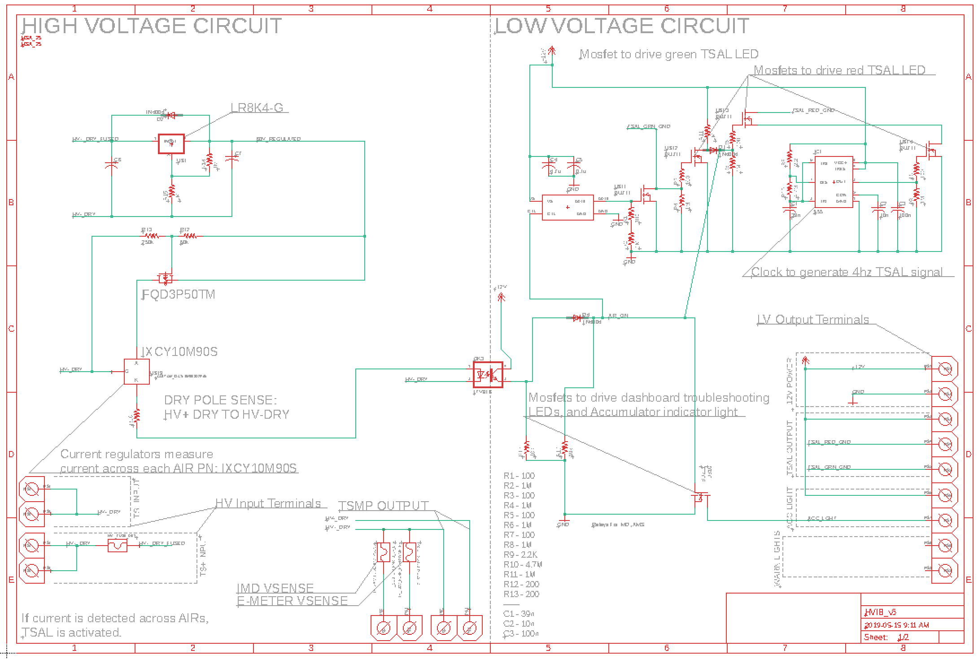

Figure 7‑6 - HVIB Circuit Schematic

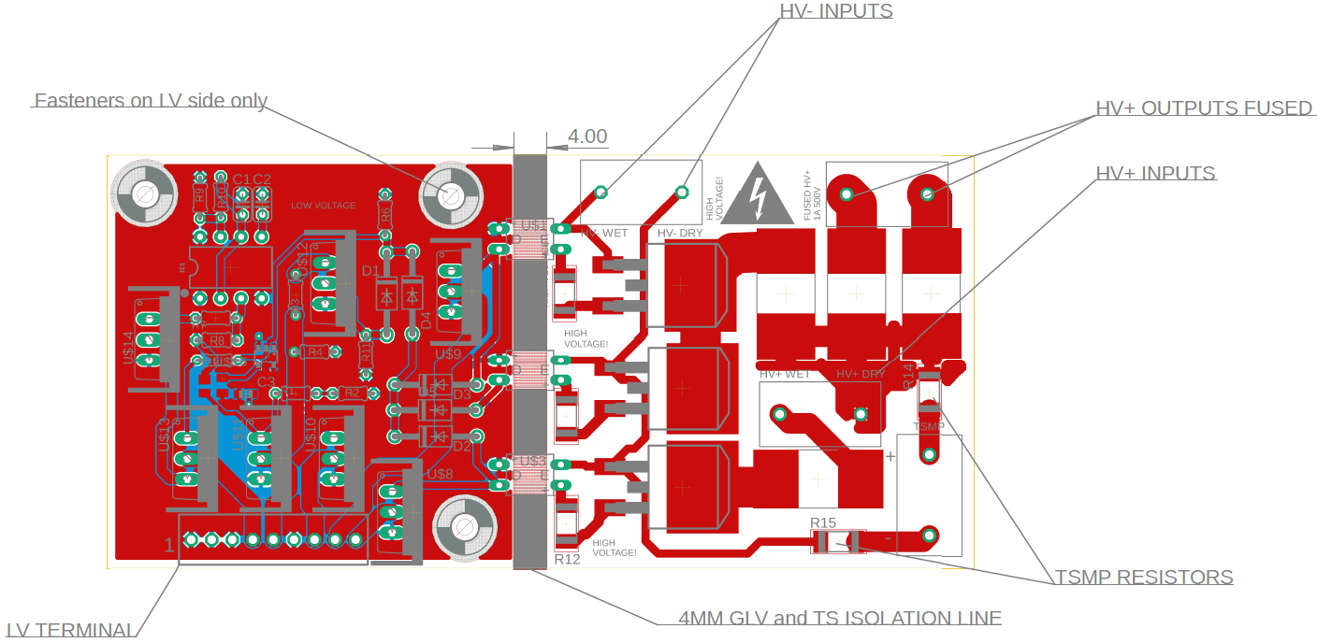

Figure 7‑7 - HVIB PCB Layout

Bill of materials listed below:

|  |  |  |  |  |  |
| --- | --- | --- | --- | --- | --- |
| Name | Part | Manufacturer | Qty | Comments | Link |
| Opto Isolator | OPI7002 | TT Electronics | 2 | 6000VDC Isolation | [Datasheet](https://www.mouser.ca/datasheet/2/414/OPI7002-7010-7320-7340_C-1291512.pdf) |
| HV Terminal | 282838-2 | TE Connectivity | 2 | 13.5A, 600V | [Datasheet](https://www.te.com/commerce/DocumentDelivery/DDEController?Action=srchrtrv&DocNm=282838&DocType=Customer+Drawing&DocLang=English) |
| TSMP Resistor | CRCW201015K0FKEF | Vishay Dale | 2 | 15kohm, 2010 package | [Datasheet](http://www.vishay.com/docs/20035/dcrcwe3.pdf) |
| 200ohm Resistor | RMCF2010JT200R | Stackpole | 3 | 2010 Package | [Datasheet](https://www.seielect.com/Catalog/SEI-RMCF_RMCP.pdf) |
| Current Regulator | IXCY10M90S | IXYS | 3 | 900V, 100mA rating | [Datasheet](http://ixapps.ixys.com/DataSheet/DS98729A(IXCP-CY10M90S).pdf) |
| LV Terminal | 1725724 | Phoenix | 1 | 9 Posn, 2.54mm Pitch, 6A | [Datasheet](https://media.digikey.com/pdf/Data%20Sheets/Phoenix%20Contact%20PDFs/1725724.pdf) |
| NCH MOSFET | PHP18NQ11T,127 | Nexperia USA, Inc | 7 | 10A Id, 200V | [Datasheet](https://assets.nexperia.com/documents/data-sheet/PHP18NQ11T.pdf) |
| MOSFET Heatsink | V7236A1 | Assmann | 7 | 1.5W Power Dissapation | [Datasheet](http://www.assmann-wsw.com/fileadmin/datasheets/ASS_0512_HS.pdf) |
| Thermal Pad | SP400-0.009-00-58 | Bergquist | 7 | TO-220 Thermal Pad | [Datasheet](https://media.digikey.com/pdf/Data%20Sheets/Bergquist%20PDFs/Sil-Pad_Selection_Guide.pdf) |
| Inverter Gate | BU4SU69G2-TR | Rohm Semiconductor | 1 | 3-16V supply | [Datasheet](http://rohmfs.rohm.com/en/products/databook/datasheet/ic/logic_switch/standard_logic/bu4su69g2-e.pdf) |
| Timer | SE555P | Texas Instruments | 1 | 555, 4.5 - 18V Supply | [Datasheet](http://www.ti.com/lit/ds/symlink/se555.pdf) |

# Appendix

## SDS (MSDS) of accumulator cell

[Link](https://cdn.shopify.com/s/files/1/0674/3651/files/lg-hg2-spec-sheet.pdf)